Finding Useful Spreadsheets on Excel:

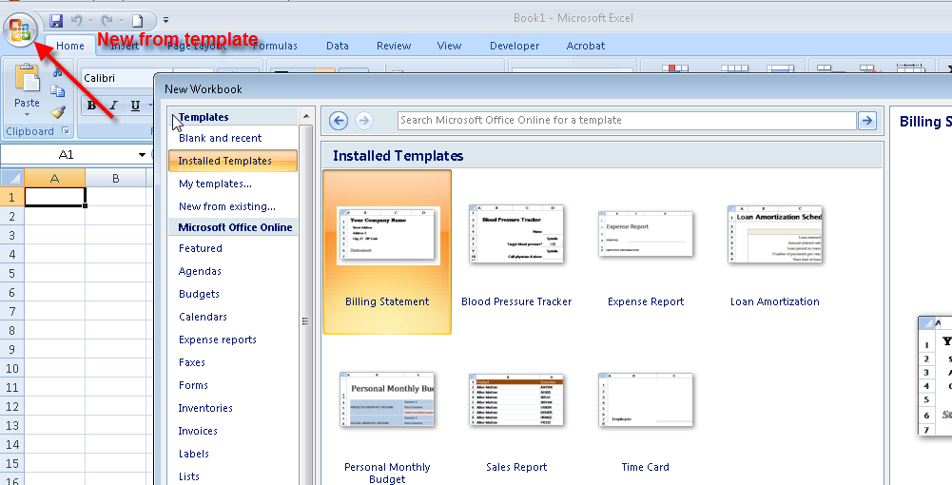

Spend a little time going through the categories and possibilities of templates on the computer and templates online. Check out the wedding expenses template and you will want to elope!

Find the spreadsheet template called College Budget:
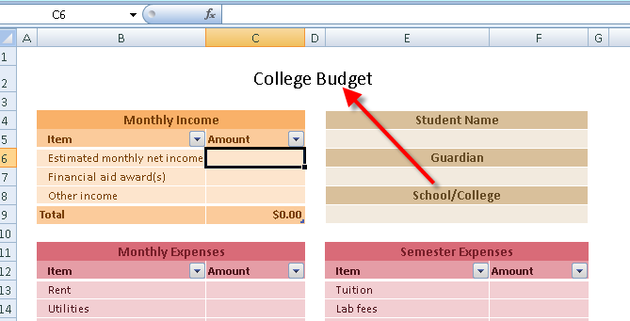
Experiment with numbers to see what results you get – fill in some “pretend” numbers in the areas for Monthly Income, Monthly Expenses, and Semester Expenses.
What formulas were used for:
Total Monthly Income?

Total Monthly Expenses?

Total Semester Expenses?

Discretionary Income?

