We're Moving to the Mountains on June 15, 2003
But I Am Not Yet Retiring from Trinity University
Bob an Erika Jensen’s Retirement Cottage
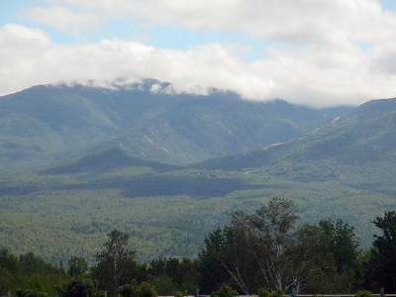 |  | 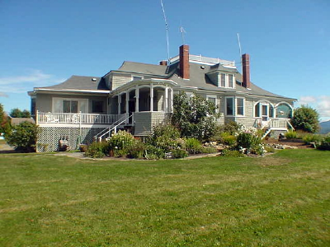
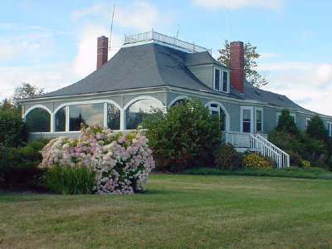 |  | 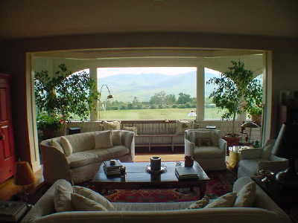
                  ☹                                                                              | 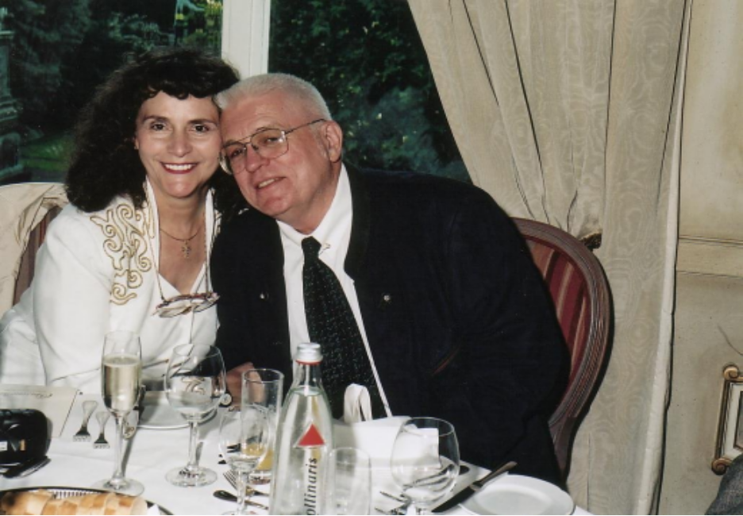 |  |                                                                             
Erika and I are capable of fast decisions. We got married two weeks after we first met almost 20 years ago. On September 1, 2002 we bought a New Hampshire house after looking at it for 15 minutes. I moved from Florida State University to Trinity University after one phone call from Ron Calgaard (former President of Trinity University). It's a darn good thing that I avoid horse sales.
The history of our new cottage is rather interesting. It was the structure called Brayton Cottage on the grounds of a huge hotel. In 1973, all the structures in the resort were demolished except for Brayton Cottage. A basement was put in where the hotel's dining room once stood atop a hill. The Brayton Cottage was then moved over this basement. The views are spectacular. The front side overlooks the Presidential Range of the White Mountains of New Hampshire. The backside overlooks the Green Mountains of Vermont. On a clear night we'll be able to look down on the lights of 27 towns. But this will not be until after June 15, 2003 when we take possession.
For a description of our new location and a description of the lupine festival across from our house, to to
http://www.photo.net/bboard/q-and-a-fetch-msg?msg_id=0027pL
A very nice and nearby inn is the Sunset Hill House, Sunset Road, Sugar Hill, NH 03585, (603)823-5522 or 800 SUN HILL --- http://www.travelguides.com/inns/full/NH/277.html
About ten miles away, you will find The Franconia Inn --- http://www.franconiainn.com/about.html
Sugar Hill is a village that has only houses, two churches, and a post office. Another village (Franconia) with some business is about five miles away. The backside of our four acres borders on a small golf course, but I don't think residents are looking forward to the arrival of the divot king.
There is an an art studio beside the house. Erika already has plans to make it a home for her bench saw, her scroll saw, her drill press, and her other heavy tools. All I'm concerned about is the speed of my Internet connection in these remote mountains.
We're a bit tired of city dwelling and the Texas heat. However, we may return to San Antonio a couple of months a year. Of course for the next year or two, I will be teaching at Trinity University about nine months per year (which is full time for Trinity).
Until the stock market improves, I have to sing for both my supper and the mortgage payments. I do not anticipate a quick recovery of the economy.
IF HAD MY LIFE TO LIVE OVER
Note: Erma Bombeck needed an organ transplant, and even though she could have been moved to the head of the waiting list, due to her prominence and wealth, she refused to do such and subsequently died from organ failure.
IF I HAD MY LIFE TO LIVE OVER - by Erma Bombeck
- I would have talked less and listened more.
- I would have invited friends over to dinner even if the carpet was stained, or the sofa faded.
- I would have eaten the popcorn in the 'good' living room and worried much less about the dirt when someone wanted to light a fire in the fireplace.
- I would have taken the time to listen to my grandfather ramble about his youth.
- I would never have insisted the car windows be rolled up on a summer day because my hair had just been teased and sprayed.
- I would have burned the pink candle sculpted like a rose before it melted in storage.
- I would have sat on the lawn with my children and not worried about grass stains.
- I would have cried and laughed less while watching television-and more while watching life.
- I would have shared more of the responsibility carried by my partner in life.
- I would have gone to bed when I was sick instead of pretending the earth would go into a holding pattern if I weren't there for the day.
- I would never have bought anything just because it was practical, wouldn't show soil, or was guaranteed to last a lifetime.
- When my kids kissed me impetuously, I would never have said, "Later. Now go get washed up for dinner."
- There would have been more "I love you's".. more "I'm sorry's" ... but mostly, given another shot at life, I would seize every minute...look at it and really see it ... live it...and never give it back.
Stop sweating the small stuff. Don't worry about who doesn't like you, who has more, or who's doing what.
Instead, let's cherish the relationships we have with those who do love us, let's think about what God HAS blessed us with.
And what we are doing each day to promote ourselves mentally, physically, emotionally, as well as spiritually. Life is too short to let it pass you by.
We only have one shot at this and then it's gone.
And so we come to the end of a momentous year of decisions in which we took a really big shot! Please pray that we made the right decision when choosing to retire in the cold, wind, snow, and mountain terrain instead balmy palm tree terrain. Happy holidays to you and your entire family.
Bob an Erika Jensen
9010 Village Drive, San Antonio, TX 78217 rjensen@trinity.edu
Home Page http://www.trinity.edu/rjensen/

We will be lonely in a remote mountain village, so we hope you will visit us after we’re settled in our new home on Sunset Hill Road in Sugar Hill, New Hampshire.

