Accounting for Derivative Financial Instruments and Hedging Activities

Bob Jensen’s home page is at http://www.trinity.edu/rjensen/
Off line --- ..\..\..\..\..\..\..\Webjen\default.htm
Robert (Bob) Jensen
Emeritus Accounting Professor From Trinity University
190 Sunset Hill Road
Sugar Hill, NH 03586
Phone: 603-823-8482
email: rjensen@trinity.edu
Bob Jensen's Technologies in Education Workshops Have Been
Presented at Over 350 Colleges and Universities
Bob Jensen's  Personal Data | Videos and Tutorials Overview  Listing of Free Videos | Bob Jensen's Threads  on Electronic Commerce, Computer Security, and Network Security | Bob Jensen's Accounting & Technology Glossaries
Bookmarks  Music & Video  Electronic Literature  and Textbooks | Archives of  New Bookmarks  Tidbits Directory | Education  Technology Updates  (Including Shared  Course Materials)  Higher Education  Controversies  Assessment Issues | Bob Jensen's Past Workshops
Fraud Main Document  Fraud Updates  Fraud Conclusions | Accounting Theory  XBRL and XML | Helpers for Choosing a Financial Advisor & Personal Finance Helpers | Accounting Information Systems

Music Links | Computers in  Education  Tutorials | Computers in  Education  Research | Accounting  Educator  Helpers | Accounting  Researcher  Helpers
Search Helpers and Electronic Libraries | Online  Accounting  Helpers | Hedge  Accounting  Glossaries & Experts  SwapValue | Bob Jensen's  Accounting  Courses | Bob Jensen's  Threads

Derivative Financial Instrument Frauds --- http://www.trinity.edu/rjensen/FraudRotten.htm#DerivativesFrauds
Off line --- ..\..\..\..\..\..\..\Webjen\FraudRotten.htm

Bob Jensen’s FAS 133-IAS 39 Tutorials --- http://www.trinity.edu/rjensen/caseans/000index.htm
Off line --- ..\..\..\..\..\..\..\Webjen\caseans\000index.htm
Bob Jensen’s Free CD --- http://www.cs.trinity.edu/~rjensen/Calgary/CD/
Off line --- CD Bookmark
FAS 133 and IAS 39 Glossary and Transcriptions of Experts Accounting for Derivative Instruments and Hedging Activities --- http://www.trinity.edu/rjensen/acct5341/speakers/133glosf.htm
Off line --- ..\..\..\..\..\..\..\Webjen\acct5341\speakers\133glosf.htm
A Condensed Multimedia Overview With Video and Audio from Experts --- http://www.cs.trinity.edu/~rjensen/000overview/mp3/133summ.htm
This file has video and audio clips of experts!
Off line --- 133summ.htm
A Longer and More Boring Introduction to FAS 133, FAS 138, and IAS 39 --- http://www.cs.trinity.edu/~rjensen/000overview/mp3/133intro.htm
This file has audio clips of experts!
Off line --- 133intro.htm
Video Tutorials on Accounting for Derivative Financial Instruments and Hedging Activities per FAS 133 in the U.S. and IAS 39 internationally --- http://www.cs.trinity.edu/~rjensen/video/acct5341/fas133/WindowsMedia/
Off line --- 133summ.htm
Flow Chart for FAS 133 and IAS 39 Accounting --- http://www.trinity.edu/rjensen/acct5341/speakers/133flow.htm
Off line --- 133flow.htm
Differences between FAS 133 and IAS 39 --- http://www.trinity.edu/rjensen/caseans/canada.htm
Off line --- ..\..\..\..\..\..\..\Webjen\caseans\Canada.htm
Intrinsic Value Versus Full Value Hedge Accounting --- http://www.trinity.edu/rjensen/caseans/IntrinsicValue.htm
Off line --- ..\..\..\..\..\..\..\Webjen\caseans\IntrinsicValue.htm
Derivative Financial Instruments Frauds ---
http://www.trinity.edu/rjensen/FraudRotten.htm#DerivativesFrauds
Off line --- 133summ.htm
FAS 133 Trips Up Fannie Mae
Off line --- 000index.htm
Hedging Paradox:
In finance, there is no way to cover your Fannie without exposing your Fannie somewhere else.
Gypsy Rose Lee would've said her fan (hedge) can only cover one Fannie cheek at a time.
Off line --- 000index.htm
Freddie Mac Paves the Way With Risk Stress Tests and Then Fails on Macro Hedge Accounting
Off line --- 000index.htm
Yield Burning Frauds
Off line --- 000index.htm
Introduction to FAS 138 (Amendments to FAS 133) and some key DIG issues at http://www.cs.trinity.edu/~rjensen/000overview/mp3/138intro.htm
Off line --- 138intro.htm
Canadian Workshop Topics --- http://www.trinity.edu/rjensen/caseans/000indexLinks.htm
Off line --- ..\..\..\..\..\..\..\Webjen\caseans\000indexLinks.htm
Tutorials and Helpers --- http://www.trinity.edu/rjensen/acct5341/speakers/133glosf.htm#Tutorials
Off line --- ..\..\..\..\..\..\..\Webjen\acct5341\speakers\133glosf.htm
”Testing and Accounting for Hedge Ineffectiveness Under FAS 133, by Angela L.J. Huang and Robert E. Jensen, Derivatives Report, February 2003, pp. 1-10. http://www.riahome.com/estore/detail.asp?ID=TDVN
I have a draft paper entitled "The Theory of Interest Rate Swap Overhedging" at http://www.trinity.edu/rjensen/315wp/315wp.htm
This is a very rough start on developing this theory. I would appreciate any feedback you can give on this paper.
Off line --- ..\..\..\..\..\..\..\Webjen\315wp\315wp.htm
This is a Good Summary of Various Forms of Business Risk --- http://www.erisk.com/portal/Resources/resources_archive.asp
- Enterprise Risk Management
- Credit Risk
- Market Risk
- Operational Risk
- Business Risk
- Other Types of Risk?

Video Tutorials on Accounting for Derivative Financial Instruments and Hedging Activities per FAS 133 in the U.S. and IAS 39 internationally --- http://www.cs.trinity.edu/~rjensen/video/acct5341/fas133/WindowsMedia/
Off line --- 133summ.htm
- Video Tutorial: Introduction to Accounting for Derivatives and Hedging ---
000FAS133introduction.wmv
Off line --- ..\..\..\..\..\..\..\Webjen\Calgary\CDfiles\video\FAS133\000FAS133introduction.wmv
- Video Tutorial: Overview of Bob Jensen's Helper Documents on Derivatives and Hedging ---
010FAS133Helpers.wmv
Off line --- ..\..\..\..\..\..\..\Webjen\Calgary\CDfiles\video\FAS133\010FAS133Helpers.wmv
- Video Tutorial: Two Cases on Accounting for Options and Intrinsic vs. Time Value Accounting --- 015FAS133options.wmv
Off line --- ..\..\..\..\..\..\..\Webjen\Calgary\CDfiles\video\FAS133\015FAS133options.wmv
- Video Tutorial: Two Cases on Accounting for Futures Contracts ---
020FAS133futures.wmv
Off line --- ..\..\..\..\..\..\..\Webjen\Calgary\CDfiles\video\FAS133\020FAS133futures.wmv
- Video Tutorial: Accounting for Interest Rate Swap Hedges and Valuation of Swaps ---
030FAS133InterestRateSwapAccounting.wmv
Off line --- ..\..\..\..\..\..\..\Webjen\Calgary\CDfiles\video\FAS133\133ex05a.wmv

My SFAS 133 and IAS 39 Glossary and Transcriptions of Experts
http://www.trinity.edu/rjensen/acct5341/speakers/133glosf.htm
Off line --- ..\..\..\..\..\..\..\Webjen\acct5341\speakers\133glosf.htm

Some Other Helpers for Accountants and Accounting Educators
Helpers for Accounting Educators --- http://www.trinity.edu/rjensen/default3.htm
Off line --- ..\..\..\..\..\..\..\Webjen\default3.htm
Accounting Theory --- http://www.trinity.edu/rjensen/theory.htm
Off line --- ..\..\..\..\..\..\..\Webjen\theory\00overview\theory.htm
XBRL and XML --- http://www.trinity.edu/rjensen/XBRLandOLAP.htm
Off line --- ..\..\..\..\..\..\..\Webjen\XBRLandOLAP.htm
Electronic Commerce --- http://www.trinity.edu/rjensen/ecommerce.htm
Off line --- ..\..\..\..\..\..\..\Webjen\ecommerce\000start.htm

The name of the game is derivatives!
Will your bonus for last year come anywhere close to $9 million?
Global commercial banks are expected to award bumper bonuses in the next three months, following a pattern set by the US investment banks in December. Forex dealers anticipate year-on-year increases of up to 50% in their annual packages, on the back of a highly lucrative year in foreign exchange as major and emerging markets currencies went haywire. An unusually active fourth quarter in particular boosted many traders' profit and loss accounts as they wound down for year-end, sending up bonus expectations accordingly. Goldman Sachs, Merrill Lynch, Morgan Stanley and Lehman Brothers were among the banks that announced their bonus payouts in December. Peers at rival banks reported that forex dealers at Morgan Stanley saw average year-on-year rises of 20%, while the very top staff in foreign exchange and derivatives may have seen as much as $9 million each. "This type of figure is not inconceivable at the top three or four banks," said one head of foreign exchange at a US bank in New York.
RiskNews Weekly on January 9, 2004

An Illustration of FAS 133 Implementation and Hedging Complexities
The bookkeeping error in which Fannie Mae failed to book $1.1 billion in derivative financial statements was reported as a computer error when implementing a new FAS 149 set of amendments to FAS 133 at Fannie Mae. The explanation is plausible, the importance of this error were probably overblown by the media.
However, Fannie May's otherwise impeccable attempts to implement FAS 133 and its amendments illustrate what a complicated complicated mess we are in today when implementing FAS 133 issued by the Financial Accounting Standards Board (FASB). The same can be said about its IAS 39 counterpart issued by the International Accounting Standards Board (IASB). These two standards and their various amendments are widely criticized and have tended to create more confusion than help among investors, analysts, accountants, banks, and other corporations.
A large part of the confusion that exists centers around the public perception of hedging. Hedging suggests elimination of risks that are hedged. In fact, however, hedging is merely a transfer from one type of risk to another type of risk. Before getting into this, however, let's review the Fannie Mae example of a really solid effort to implement FAS 133 and its amendments.

What is Fannie Mae? --- Federal National Mortgage Association --- http://www.primecoastmortgage.com/Fannie_Mae.htm
The role of Fannie Mae and the secondary mortgage market in housing finance
Fannie Mae plays a vital role in financing mortgages and increasing homeownership opportunities for more Americans. A privatization success story, Fannie Mae began in 1938 as an agency of the federal government, created to bring stability to the U.S. housing market. In 1968, Fannie Mae became a privately-owned and - managed corporation. At that time, the U.S. Congress rechartered Fannie Mae as a private company, mandating that it operate with private capital on a self-sustaining basis to enhance the flow of funds through the secondary market to American home buyers.
Fannie Mae operates exclusively in the secondary mortgage market - providing support to mortgage lending institutions in the primary market. Lenders who originate loans in the primary mortgage market may either hold the loans in their portfolios or sell them in the secondary mortgage market. By selling their loans in the secondary market, lenders are able to obtain additional funds with which to make more loans to home buyers.
The secondary mortgage market helps accomplish the following important housing objectives:
- it addresses imbalances of mortgage credit among regions of the United States by making funds available to capital-deficient areas of the country to finance new mortgage originations;
- it allows lenders to originate mortgages for sale rather than for portfolio investment;
- it standardizes mortgage loans, thereby attracting investors who traditionally have not invested in the primary market, further strengthening this market.
Fannie Mae's impact on housing needs
Fannie Mae is the nation's largest investor in home mortgages today. The corporation has provided home financing for over 32 million American families since its creation in 1938. Fannie Mae currently owns in its portfolio, or holds in trust for investors, one out of every five mortgages in the United States.
In 1994, Fannie Mae announced its Trillion Dollar Commitment to provide $1 trillion by the year 2000 to finance homes for over 10 million families most in need. This targeted housing finance initiative is serving families with incomes below the median for their area, minorities and new immigrants, families who live in central cities and distressed communities, and people with special housing needs.
Through its Trillion Dollar Commitment, Fannie Mae provides renters in America the information they need to buy homes, develops specialized products and services to break down arbitrary barriers to getting home mortgages, and focuses on eliminating lending discrimination in the housing finance industry.
Fannie Mae's homepage is at http://www.fanniemae.com/index.jhtml
Fannie Mae FAQs --- http://www.fanniemae.com/faq/index.jhtml?p=FAQ

Statement from the CEO of Fannie Mae Regarding FAS 133 Reporting Prior to the October 29, 2003 Adverse News Report --- http://www.fanniemae.com/ceoanswers/derivativesaccounting.jhtml
Why do you have confidence that you have done your derivative accounting properly?
First, Fannie Mae filed fully audited financial statements with the SEC when we filed our Form 10 and Form 10-K on March 31, 2003. And as part of the registration process, the SEC reviewed our financial disclosures and critical accounting policies. As CEO of an SEC-registered company, I personally certified that our financial statements are accurate, as did our Chief Financial Officer, Tim Howard. Further, on May 14, 2003, Fannie Mae filed its Form 10-Q and will file all required SEC reports going forward.
More specifically, years before the FAS 133 accounting practices pertaining to derivatives were adopted, we worked closely with the Financial Accounting Standards Board (FASB) to make sure we understood how the new requirements would apply to our business. We then made substantial investments in additional accounting staff and new systems to track our derivatives transactions, given the unique challenges of these transactions. For example, we need to match up each derivative transaction -- one by one -- with the liability that we use the derivative to hedge.
Let me walk through how we account for our derivatives:
- First, we use derivatives primarily for two purposes: as substitutes for notes and bonds we issue in the debt markets and to hedge against fluctuations in interest rates on planned debt issuances.
- Second, we have a very controlled process to ensure against management mistakes.
  - Importantly, our accounting function does NOT reside within the business units. Those entering into business transactions and accountable for the business results do not determine the accounting of those transactions.
  - In anticipation of adopting FAS 133, we catalogued each type of derivative transaction done by Fannie Mae. As part of our implementation process, we consulted with our independent auditors -- KPMG -- about the appropriateness of our FAS 133 accounting policies, interpretations, and systems.
  - We continue today to maintain a current catalogue of each type of derivative transaction done and to set our accounting policy at the transaction level. We don't assume that the correct treatment for one transaction is automatically the correct or best treatment for a different transaction.
  - Prior to entering into a new type of derivative transaction, the business unit will describe the intended transaction. Our Controller will then recommend an accounting treatment. Our policy is to have the Controllers Office discuss this recommended accounting treatment with our outside independent auditors and to update the derivatives accounting policy that governs the transactions the business units can enter into. Only when the policy is updated can the transaction be completed.
  - The hedge accounting treatment for each individual transaction is determined -- and documented in writing -- before we enter into the transaction. And it cannot subsequently be changed.
  - On a daily basis all hedging activity is reported to our Controllers Office, which monitors hedge performance and accounts for the hedge.
  - On an annual basis Fannie Mae's internal audit department performs a comprehensive audit of our hedging activity to ensure compliance with our Hedge Accounting Guidelines and that strong internal controls are in place. Fannie Mae's internal audit department reports directly to the fully independent Audit Committee of our Board of Directors, which reviews its work -- including the derivatives audit -- every year.
It is because of our disciplined approach to accounting that we have experienced such large swings in our GAAP income over the past two years. In our use of derivatives, we look to execute the most efficient hedge for the business -- we don't approach our hedging with a specific accounting result in mind. We fully disclose the accounting implications of our decisions, and each quarter we report to investors both our core business earnings and our GAAP earnings, and reconcile the two.
To date, of the 14 housing GSEs (including the 12 Federal Home Loan Banks), Fannie Mae is the only one to have filed its fully audited -- and management certified -- financial statements with the SEC. The fully independent Audit Committee of our Board of Directors oversees our internal auditor, outside auditor, and our financial reporting. That gives us additional confidence in our financial statements, and should give investors confidence too.
Fannie Mae provides a comparison of our GAAP results to our non-GAAP financial measures.

In May of 2003, the Financial Accounting Standards Board (FASB) issued Statement No. 149, Amendment of Statement 133 on Derivative Instruments and Hedging Activities. The Statement amends and clarifies accounting for derivative instruments, including certain derivative instruments embedded in other contracts, and for hedging activities under Statement 133 --- http://www.fasb.org/news/nr043003.shtml
Norwalk, CT, April 30, 2003—Today the Financial Accounting Standards Board (FASB) issued Statement No. 149, Amendment of Statement 133 on Derivative Instruments and Hedging Activities. The Statement amends and clarifies accounting for derivative instruments, including certain derivative instruments embedded in other contracts, and for hedging activities under Statement 133.
The new guidance amends Statement 133 for decisions made:
- as part of the Derivatives Implementation Group process that effectively required amendments to Statement 133,
- in connection with other Board projects dealing with financial instruments, and
- regarding implementation issues raised in relation to the application of the definition of a derivative, particularly regarding the meaning of an “underlying” and the characteristics of a derivative that contains financing components.
The amendments set forth in Statement 149 improve financial reporting by requiring that contracts with comparable characteristics be accounted for similarly. In particular, this Statement clarifies under what circumstances a contract with an initial net investment meets the characteristic of a derivative as discussed in Statement 133. In addition, it clarifies when a derivative contains a financing component that warrants special reporting in the statement of cash flows. Statement 149 amends certain other existing pronouncements. Those changes will result in more consistent reporting of contracts that are derivatives in their entirety or that contain embedded derivatives that warrant separate accounting.

October 1, 2003 Accounting Tutorial Provided to the Public by Fannie Mae --- http://www.fanniemae.com/ir/accountingtutorial.jhtml
This virtual presentation is copyrighted material of Fannie Mae. No recording, broadcast, or other distribution of this virtual presentation, or any part of the virtual presentation, is permitted without Fannie Mae's permission. Your participation in this virtual presentation implies your consent.

October 29, 2003 Error Announcement: FAS 133/149 Trips Up Fannie Mae
Statement by Jayne Shontell Fannie Mae Senior Vice President, Investor Relations October 30, 2003 --- http://www.fanniemae.com/ir/issues/financial/103003.jhtml
As you know, yesterday Fannie Mae filed a Form 8-K/A with the SEC amending our third quarter press release to correct computational errors in that release. There were honest mistakes made in a spreadsheet used in the implementation of a new accounting standard.
As we also reported, we discovered the errors in the course of the standard review in preparation of the company's financial statements to be included in Form 10-Q for the third quarter, and were primarily made in conjunction with the implementation of FAS 149.
The bottom line is that the correction has no impact on our income statement, but resulted in increases to unrealized gains on securities, accumulated other comprehensive income, and total shareholder equity (of $1.279 billion, $1.136 billion, and $1.136 billion, respectively).
I would like to explain what happened yesterday regarding the release of the information.
We were preparing to file the Form 8-K/A as required, and to ensure the maximum disclosure, we also were preparing to issue a press release with a statement announcing the filing. We contacted the business service we use to distribute press releases to inform the service what we planned to do once the documents were finalized. Before we even sent the business service the documents to be disclosed, the service -- on its own and without our prior knowledge or authorization -- put forth a statement, attributed to Fannie Mae, "killing" our previously issued October 16 press release. Shortly thereafter, our stock began to trade down. We proceeded to file the 8-K/A and issued our statement as soon as we could.
Let me reiterate that the correction had to do with a computational error in performing complicated calculations required in the implementation of FAS 149.
FAS 149 was issued in April. It required Fannie Mae to mark to market the majority of mortgage commitments we had made, which were previously not part of our financial statements. The new requirement was effective July 1. In adopting a new accounting standard in a short period of time, Fannie Mae had to put in place a system and process to capture all open commitments and mark them to market. To implement this standard, Fannie Mae utilized information from its internal, automated systems in conjunction with spreadsheets that made additional calculations necessary under the new rule. Fannie Mae is already in the process of updating its automated systems to account for the mortgage commitments under FAS 149.
Our accounting team discovered the errors in the normal course of preparing our financial statements for inclusion in our 10-Q. They immediately notified management and our independent auditor, KPMG. Management in turn notified the Audit Committee of the Fannie Mae Board of Directors and our regulator.
We continue to be proud of our accounting processes and controls. Far from being a failure of our accounting system, this event demonstrates that our accounting processes and controls work as they should. While we would have obviously preferred the error did not occur in the October 16 press release, we are pleased that the error was corrected before we file our financial statements in our 10-Q.

October 31, 2003 Quotation from The Wall Street Journal
Fannie Mae had previously argued that it had a far better lock on its accounting than Freddie Mac, hoping to cast itself as a more responsible and sophisticated operation that didn't need much more scrutiny. Fannie Mae went so far as to hold an accounting "tutorial" earlier this month to explain derivatives accounting to investors, analysts and reporters. Yet it was in derivatives accounting that its stumble came.
Patrick Bartta and John D Mckinnon (See below)
Note from Bob Jensen
You can read Fannie Mae's Derivatives Accounting Tutorial at http://www.fanniemae.com/ir/pdf/tutorial10012003.pdf
"Fannie Mae Made $1.1 Billion Error In Its Accounting: Understatement of Equity Renews Calls For Oversight of Two Mortgage Giants," by Patrick Bartta and John D. McKinnon, The Wall Street Journal, October 31, 2003 --- http://online.wsj.com/article/0,,SB10674573311089700-search,00.html?collection=wsjie%2F30day&vql_string=Freddie%3Cin%3E%28article%2Dbody%29
Fannie Mae, the mortgage-financing giant already facing a crescendo of criticism about its financial oversight, said it miscalculated the value of its mortgage commitments, forcing it to make a $1.1 billion restatement of its stockholder equity.
The government-chartered company, which bills itself as the world's largest nonbank financial institution, released a revised third-quarter financial statement Wednesday correcting what it called "computational errors" that appeared when the results were first reported earlier this month. The restated figures were higher and didn't alter the company's profit, which was $2.67 billion in the third quarter, up 168% from a year earlier.
But the episode instantly reinforced fears that Fannie Mae and its smaller sibling Freddie Mac lack the necessary skills to operate their massive and complex businesses, which some investors, rivals and political critics worry could pose risk to the nation's financial system if not properly managed. Though the companies are not formally backed by a government guarantee, investors generally assume the government would step in to bail the companies out in an emergency, given their critical importance to the housing and broader financial markets.
Spreads between most Fannie Mae debt issues and comparable Treasury securities widened Wednesday. Investors pummeled the stock after the news was announced, though the stock recovered some ground by the end of the day. In 4 p.m. New York Stock exchange composite trading, Fannie Mae's shares were down 2.4% at $73.10.
Lawmakers and Treasury officials were already debating whether to tighten oversight of Fannie and Freddie after Freddie Mac disclosed its own accounting problems earlier this year. Freddie Mac's problems, which involved understating income by at least $4.5 billion, led to a major management shake-up, including the ouster of two chief executive officers. Freddie Mac used financial transactions to shift excess earnings into the future and mask the company's volatility.
Both companies "have a credibility problem, and this only makes it worse," said James Bianco, president of Bianco Research LLC, a Chicago-based investment-research firm who has been critical of the two companies. He said it highlights how too few people have a firm grasp on Fannie Mae's arcane accounting and overall financial position, even as Wall Street analysts continue to tout the company's stock. "Investors look at this stuff, throw their arms up in the air [and say], 'We don't understand this stuff, you don't understand this stuff, and the companies don't understand this stuff, but it doesn't matter, because the government is going to back it anyway.' "
Fannie Mae had previously argued that it had a far better lock on its accounting than Freddie Mac, hoping to cast itself as a more responsible and sophisticated operation that didn't need much more scrutiny. Fannie Mae went so far as to hold an accounting "tutorial" earlier this month to explain derivatives accounting to investors, analysts and reporters. Yet it was in derivatives accounting that its stumble came.
Continued in the article.

Question
How can failure to book derivatives fair value of $1.1 billion not have any impact on earnings? If this is the case, what's the big sweat over failure to book the derivatives?
Answer (I include the FAS 149 amendments of FAS 133 as being part and parcel to FAS 133 itself.)
If the unbooked $1.1 fair value of the derivatives had instead been properly booked according to FAS133/IAS39 rules, the balance sheet assets and liabilities would change by $1.1 billion. If these derivatives had been speculations or did not otherwise qualify for special hedge accounting treatment under FAS133/IAS39 rules, they would have impacted earnings by $1.1 billion. But these derivatives were apparently hedges, and Fannie Mae tries to imply that its accounting error is no big sweat. The CEO of Fannie Mae asserts that derivatives are used primarily for two purposes:
... we use derivatives primarily for two purposes: as substitutes for notes and bonds we issue in the debt markets and to hedge against fluctuations in interest rates on planned debt issuances.
Statement from the CEO of Fannie Mae Regarding FAS 133 Reporting Prior to the October 29, 2003 Adverse News Report --- http://www.fanniemae.com/ceoanswers/derivativesaccounting.jhtml
First I might note that when derivatives are used as substitutes for debt issuances, their changes in value would affect current earnings to the extent that they are not used for hedging purposes under FAS 133 rules. However, I seriously doubt that Fannie Mae is allowed to speculate using derivatives? As "hedges against fluctuations in interest rates" their changes in value would not affect current earnings to the extent that the hedges are effective. The reason is that FAS 133 provides complex ways to avoid earnings impacts of changes in value of hedging derivatives. This is complex in the sense how it is done varies with cash flow hedges versus fair value hedges of booked hedge items versus fair value hedges of unbooked hedge items such as "planned debt issuances." In the case of forecasted transactions like "planned debt issuances," the hedges are most likely cash flow hedges of interest rate risk in forecasted transactions much like Example 5 in Appendix B of FAS 133. See my video of Example 5:
Video Tutorial: Accounting for Interest Rate Swap Hedges and Valuation of Swaps ---
030FAS133InterestRateSwapAccounting.wmv --- http://www.cs.trinity.edu/~rjensen/video/acct5341/fas133/WindowsMedia/030FAS133InterestRateSwap

So where's the big sweat in FAS 133 and IAS reporting rules as they stand today?
The big sweat is that there are two types of hedges other than foreign currency hedges. One type is a cash flow hedge and the other type is a fair value hedge. What people often fail to realize is that you can't be hedged both ways. If a company has cash flow risk and hedges that risk, it creates fair value risk. If a company has fair value risk and hedges that risk, it creates cash flow risk. If Fannie Mae hedged interest rate cash flow risk, then it created fair value risk on the combined fair value of its hedged items and hedging instruments. If it hedged fair value, it created cash flow risk.
If Fannie Mae's erroneously unbooked derivatives qualified for special hedge accounting under FAS133/IAS39 rules, then the offset to changes in booked fair value would bypass earnings. The ineffective portion of the hedge does impact current earnings. However, since Fannie Mae primarily hedges interest rate movements (probably with interest rate swaps), the hedges most likely qualified for "The Shortcut Method" under FAS 133 (see Paragraph 132) and would be deemed to be perfectly effective at the beginning of the hedge.
Hence Fannie Mae most likely is correct in contending that its failure to book the $1.1 billion in derivatives under FAS 133 would not have impacted earnings provided both the hedges and the hedged items were carried to maturity. The risk in not booking the derivatives (in terms of earnings) lies in the likely case that the hedged items and the hedges might not be carried to maturity. Failure to book the $1.1 billion hides the enormous risk of a hit on earnings if customers pay off loans early (as is likely the case if interest rates drop) or that Fannie Mae sells the loans before maturity (as is common with Fannie Mae).

From The Wall Street Journal Accounting Educators' Reviews on November 7, 2003
TITLE: Fannie Mae Makes $1.1 Billion Error in Its Accounting
REPORTER: Patrick Barta and John D. McKinnon
DATE: Oct 30, 2003
PAGE: A1
LINK: http://online.wsj.com/article/0,,SB10674573311089700,00.html
TOPICS: Advanced Financial Accounting, Audit Report, Auditing, Derivatives, Fair Value Accounting, Hedging
SUMMARY: Fannie Mae made an error in applying the new FAS149 requirements to mark loan commitments to market, in accordance with derivative accounting under FAS 133, that was required to be implemented in 3rd quarter reporting. Fannie Mae argues that this was not a systemic problem, but merely resulted from human error in manual systems that are being used temporarily in order to implement the new requirement quickly.
QUESTIONS:
1.) The first paragraph describes the changes from revising their third quarter financial statements as a "restatement of stockholder equity"and the second paragraph indicates that "the restated figures...didn't alter the company's profit..." How is it possible to change total stockholders' equity and not affect net income? What measure of reported performance do you think was affected by this change? Support your answer and include definitions of appropriate terms in doing so.
2.) Cite statements from the article which characterize the reaction to Fannie Mae's announcement of the accounting error. Why has the reaction been so negative even though the impact of the accounting error on stockholders' equity was positive?
3.) At the end of the article, the author indicates that the problem giving rise to this restatement was "tied in part to an obscure accounting provision, known as Financial Accounting Standard No. 149." What is the subject of that standard? Do you think it is "obscure"? What do you think makes the popular business press use this description?
4.) The author describes the loan commitments that are the subject of this accounting error near the end of the article. What provision in FAS 49 requires that these commitments be marked to market value "and hence record any unrealized changes in value of those commitments despite whatever price the company agrees to pay for the loans"? What type of accounting treatment for such commitments could result in an impact on stockholders' equity, but not net income, as is the case at hand?
5.) The impact on stockholders' equity was positive--an unrealized gain on the value of the loan commitments undertaken by Fannie Mae. What does that say about the terms of these loan commitment contracts?
6.) Suppose you are an auditor and Fannie Mae is your client. What impact does this problem have on your plans for the year-end audit? Do you have any responsibility associated with the problematic third quarter report, even if that report was labeled "unaudited"?
Reviewed By: Judy Beckman, University of Rhode Island
Reviewed By: Benson Wier, Virginia Commonwealth University
Reviewed By: Kimberly Dunn, Florida Atlantic University
--- RELATED ARTICLES ---
TITLE: Review & Outlook: Fannie's Black Box
REPORTER: WSJ Editors
PAGE: A12
ISSUE: Oct 31, 2003
LINK: http://online.wsj.com/article/0,,SB106755988050523700,00.html

.

The links to five cases on hedging strategies and accounting under new rules for accounting for derivative financial instruments and hedging activities are as follows:
MarginWHEW Bank Case (interest rate profit hedging with 30 Eurodollar futures contracts)
http://www.trinity.edu/rjensen/caseans/285case.htm
Off line --- 133summ.htm
The Excel spreadsheet is at http://www.trinity.edu/rjensen/caseans/xls/285wp/285wp.xls
Off line --- 133summ.htm
Margin OOPS Bank Case (interest rate profit hedging with 75 Eurodollar futures contracts)
http://www.trinity.edu/rjensen/caseans/285case.htm
Off line --- 133summ.htm
You can access the MarginOOPS Bank Case with buttons at the bottom of the screen.
The Excel spreadsheet is at http://www.trinity.edu/rjensen/caseans/xls/286wp/286wp.xls
Off line --- 133summ.htm
CapIT Corporation Case (interest rate caps with Eurodollar interest rate put options taken from the Wall Street Journal)
Off line --- 133summ.htmhttp://www.trinity.edu/rjensen/caseans/ccase.htm
Off line --- 133summ.htm
The Excel spreadsheet is at http://www.trinity.edu/rjensen/caseans/xls/283wp/283wp.xls
Off line --- 133summ.htm
FloorIT Bank Case (interest rate floors with Eurodollar interest rate call options taken from the Wall Street Journal)
http://www.trinity.edu/rjensen/caseans/ccase.htm
You can access the FloorIT Bank Case with buttons at the bottom of the screen.
The Excel spreadsheet is at http://www.trinity.edu/rjensen/caseans/xls/284wp/284wp.xls
Off line --- 133summ.htm
Mexcobre Case (a complex international hedging case involving a copper price swap)
http://www.trinity.edu/rjensen/caseans/133sp.htm
Off line --- 133summ.htm
The Excel spreadsheet is at http://www.trinity.edu/rjensen/caseans/xls/mexcobre/133spans.xls
Off line --- 133summ.htm
Big Wheels Cross-Currency Swap Case, Student Project by Rachel Grant, Accounting 5341, Trinity University, Spring 2000
http://www.trinity.edu/rjensen/acct5341/projects/sp2000/grant/StartPage.htm
Off line --- 133summ.htm

The Hubbard and Jensen paper on Example 5 of FAS 133 (that points out some errors in the Example 5) can be downloaded as follows:
http://www.trinity.edu/rjensen/caseans/133ex05.htm
Off line --- 133summ.htm
The Excel workbook is at http://www.cs.trinity.edu/~rjensen/133ex05a.xls
Off line --- 133summ.htm
The Hubbard and Jensen explanation of Example 2 of FAS 133 can be downloaded as follows:
http://www.trinity.edu/rjensen/caseans/294wp.doc
Off line --- 133summ.htm
The Excel workbook is at http://www.cs.trinity.edu/~rjensen/133ex02a.xls
Off line --- 133summ.htm

Readers may want to download one or more of my Excel files linked at http://www.cs.trinity.edu/~rjensen/13300tut.htm
Some solution files have been temporarily removed so that my students may temporarily not access the answers. In particular, my Excel spreadsheets for FAS 133 Appendix B Examples 1-10 have temporarily been removed. If you are not one of my students, you may contact me for a the solution files at rjensen@trinity.edu .

I wrote a document (screen play? short story? tutorial? case?) that is a takeoff on the Muppets. It is entitled "Clyde Gives Brother Hat a Lesson in Arbitrage" and can be found at http://www.trinity.edu/rjensen/acct5341/speakers/muppets.htm
Off line --- 133summ.htm

Readers may also want to download the excellent FAS 133 cases by Teets and Uhl at http://www.gonzaga.edu/faculty/teets/index0.html

A listing of various solution files can be found at http://www.cs.trinity.edu/~rjensen/
These include my spreadsheet extensions of the FAS 133 examples. For example, file names for some of these examples are as follows:
Excel Spreadsheet Example | File Name
FAS 133 Example 01 | 133ex0a1.xls
FAS 133 Example 02 | 133ex02a.xls
FAS 133 Example 03 | 133ex03a.xls
FAS 133 Example 04 | 133ex04a.xls
FAS 133 Example 05 | 133ex0a5.xls
FAS 133 Example 06 | 133ex06a.xls
FAS 133 Example 07 | 133ex07a.xls
FAS 133 Example 08 | 133ex08a.xls
FAS 133 Example 09 | 133ex09a.xls
FAS 133 Example 10 | 133ex10a.xls
Others are available
Instructions are given at http://www.cs.trinity.edu/~rjensen/13300tut.htm
Some solution files have been temporarily removed so that my students may temporarily not access the answers. In particular, my Excel spreadsheets for FAS 133 Appendix B Examples 1-10 have temporarily been removed. If you are not one of my students, you may contact me for a the solution files at rjensen@trinity.edu .
My course syllabus, helpers, and assignments --- http://www.trinity.edu/rjensen/acct5341/index.htm

Recommended Tutorials on Derivative Financial Instruments (but not about FAS 133 or IAS 39)
- You might start at http://www.finpipe.com/derivatives.htm.
- Then you can try Financial Derivatives in Plain English --- http://www.iol.ie/~aibtreas/derivs-pe/
- For details on products and how they work in practice, I like the following tutorial/education websites:
CBOE --- http://www.cboe.com/education/
CBOT --- http://www.cbot.com/ourproducts/index.html
CME --- http://www.cme.com/educational/index.html
Recommended Tutorials on FAS 133
- One of the best documents the FASB generated for FAS 133 implementation is called "summary of Derivative Types." This document also explains how to value certain types. It can be downloaded free from at http://www.rutgers.edu/Accounting/raw/fasb/derivsum.exe
- The Appendix B examples in FAS 133. You can also download Excel worksheet tutorials on the first 10 examples in files 133ex01a.xls through 133ex10.xls at http://www.cs.trinity.edu/~rjensen/
Instructions are given at http://www.cs.trinity.edu/~rjensen/13300tut.htm
- Bob Jensen's cases indexed at http://www.trinity.edu/rjensen/caseans/000index.htm
- The FASB's CD-ROM Self-Study CPE Training Course and Research Tool http://www.rutgers.edu/Accounting/raw/fasb/CDROM133.html
- The FASB provides some new examples illustrating the FAS 138 Amendments to FAS 133 at http://www.rutgers.edu/Accounting/raw/fasb/derivatives/examplespg.html
- Implementation Guidelines on IAS 39 --- http://www.iasc.org.uk/frame/cen2_139.htm
- The excellent tutorials entitled Introductory Cases on Accounting for Derivative Instruments and Hedging Activities by Walter R. Teets and Robert Uhl available free from http://www.gonzaga.edu/faculty/teets/index0.html.
- Accounting Firm Helpers
  - KPMG Book Derivatives and Hedging Handbook issued by KPMG Peat Marwick LLP in July 1998). The book in hard copy or PDF versions can be ordered at http://www.us.kpmg.com/fs/publications/banking/deriv.html.
  - PwC Book that I cannot find an online reference to is the PricewaterhouseCoopers book entitled A Guide for Derivative Instruments and Hedging Activities. PwC also has a book entitled FAS 133: New Rules for Derivatives by Robert Sullivan and Lou Le Guyader. Another PwC book is entitled Derivatives and the Internal Auditor. You can order all PwC books and other risk publications at http://www.riskpublications.com/.

Recommended Glossaries
Bob Jensen's FAS 133 Glossary on Derivative Financial Instruments and Hedging Activities
Also see comprehensive risk and trading glossaries such as the ones listed below that provide broader coverage of derivatives instruments terminology but almost nothing in terms of FAS 133, FAS 138, and IAS39:
- http://risk.ifci.ch/SiteMap.htm
- http://www.margrabe.com/Dictionary.html
- http://www.adtrading.com/glossary/glossary.htm
- Related glossaries are listed at http://www.trinity.edu/rjensen/bookbus.htm
Off line --- 133summ.htm

Interest Rate Swap Valuation, Forward Rate Derivation, and Yield Curves
for FAS 133 and IAS 39 on Accounting for Derivative Financial Instruments
Bob Jensen at Trinity University
Introduction
Short-Cut Method for Interest Rate Swaps
Yield Curve and Forward Rate Calculations
Example 5 from Appendix B of FAS 133
Excerpts from the IAS 39 November 2001 Implementation and Guidance Supplement
Legal Settlement Exit Value Amortization Rate Accounting for
Custom Interest Rate Swaps Having No Market Trading
Casting out on the Internet often results in a catch
Concept of Fair Value --- http://www.trinity.edu/rjensen/acct5341/speakers/133glosf.htm#FairValue
Note the book entitled PRICING DERIVATIVE SECURITIES, by T W Epps (University of Virginia, USA) The book is published by World Scientific --- http://www.worldscibooks.com/economics/4415.html
Contents:
- Preliminaries:
- Introduction and Overview
- Mathematical Preparation
- Tools for Continuous-Time Models
- Pricing Theory:
- Dynamics-Free Pricing
- Pricing Under Bernoulli Dynamics
- Black-Scholes Dynamics
- American Options and 'Exotics'
- Models with Uncertain Volatility
- Discontinuous Processes
- Interest-Rate Dynamics
- Computational Methods:
- Simulation
- Solving PDEs Numerically
- Programs
- Computer Programs
- Errata

Introduction
An interest rate swap is a transaction in which two parties exchange interest payment streams of differing character based on an underlying principal amount. As in all other swaps, the swap is a portfolio of forward contracts. Swaps are the most common form of hedging risk using financial instruments derivatives. Although forward contracting dates back prior to 200 B.C., interest rate swaps were invented in a swap deal put together by Salamon Brothers and Bankers Trust for IBM in 1984.
I suggest that readers commence with the fundamentals Basics are explained in the early part of "Summary of Derivative Types." This document also explains how to value certain types. It can be downloaded free from at http://www.rutgers.edu/Accounting/raw/fasb/derivsum.exe
Trinity students may find the file on the path J:\courses\acct5341\fasb\sfas133\derivsum22.doc
The most typical interest rate swaps entail swapping fixed rates for variable rates and vice versa. For instance, in FAS 133, Example 2 beginning in Paragraph 111 illustrates a fair value hedge and Example 5 beginning in Paragraph 131 illustrates a cash flow hedge. These are explained in greater detail in the following documents:
http://www.trinity.edu/rjensen/caseans/294wp.doc
The Excel workbook is at http://www.cs.trinity.edu/~rjensen/133ex02a.xls
http://www.trinity.edu/rjensen/caseans/133ex05.htm
The Excel workbook is at http://www.cs.trinity.edu/~rjensen/133ex05a.xls
A short tutorial on interest rate swaps is given at http://home.earthlink.net/~green/whatisan.htm. A good place to start in learning about how interest rate swaps work in practice is the CBOT tutorial at http://www.cbot.com/ourproducts/financial/agencystrat3rd.html. A very interesting (not free) swap calculator is given by TheBEAST.COM at http://www.thebeast.com/02_products/beast_help/ScreenSwapCalculator.htm
A tutorial can be found at http://www.thebeast.com/02_products/beastonline_gettingstarted.html
The two main types of interest rate swaps are coupon swap and basis swap. In a coupon swap or fixed-floating swap, one party pays a fixed rate calculated at the time of trade as a spread to a particular Treasury bond, and the other side pays a floating rate that resets periodically throughout the life of the deal against a designated index. In a basis swap or floating-to-floating swap is the swapping of one variable rate for another variable rate for purposes of changing the net interest rate or foreign currency risk. A basis swap (or yield curve swap) is an exchange of interest rates at two different points along the yield curve. This allows investors to bet on the slope of the yield curve. For example, an investor might arrange to borrow at six-month LIBOR but lend at the 10-year T-Bond rate, where interest rates are set twice each year. This swap is really two swaps combined: floating T-bill for floating T-bonds, plus a pure-vanilla swap between LIBOR and T-bills. Basis swaps are discussed in Paragraph 28d on Page 19, Paragraph 161 on Page 84, and Paragraphs 391-395 on Pages 178-179 of FAS 133.
The term "swap spread" applies to the credit component of interest rate risk. Assume a U.S. Treasury bill rate is a risk-free rate. You can read the following at http://www.cbot.com/ourproducts/financial/agencystrat3rd.html
The swap spread represents the credit risk in the swap relative to the corresponding risk-free Treasury yield. It is the price tag on the actuarial risk that one of the parties to the swap will fail to make a payment. The Treasury yield provides the foundation in computing this spread, because the U.S. Treasury is a risk-free borrower. It does not default on its interest payments.
Since the swap rate is the sum of the Treasury yield and the swap spread, a well-known statistical rule breaks its volatility into three components:
Swap Rate Variance = Treasury Yield Variance
+ Swap Spread Variance
+ 2 x Covariance of Treasury Yield and Swap Spread
Taken over long time spans (e.g., quarter-to-quarter or annual), changes in the 10-year swap spread exhibit a small but reliably positive covariance with changes in the 10-year Treasury yield. For practical purposes this means that as Treasury yield levels rise and fall over, say, the course of the business cycle, the credit risk in interest rate swaps tends to rise and fall with them.
However as Figure 1 illustrates, high-frequency (e.g., day-to-day or week-to-week) moves in swap spreads and Treasury yields tend to be uncorrelated. Their covariance is close to zero. Thus, for holding periods that cover very short time spans, this stylized fact allows simplification of the preceding formula into the following approximation:
This rule of thumb allows attribution of the variability in swap rates in ways that are useful for hedgers. For example, during the five years from 1993 through 1997, 99% of week-to-week variability in 10-year swap rates derived from variability in the 10-year Treasury yield. Variability in the 10-year swap spread accounted for just 1%.
The FAS 138 amendments to FAS 133 allow for benchmarking credit spreads. See Benchmark Interest Rate.
Basis risk arises when the hedging index differs from the index of the exposed risk. Examples might be the following: (1)The risk of loss from using a German mark position to offset Swiss franc exposure or using a shorter-termed derivative to hedge long-term interest rate exposures; (2) Exposure to loss from a maturity mismatch caused, for example, by a shift or change in the shape of the yield curve; (3) The variability of return stemming from possible changes in the price basis, or spread between two rates or indexes. This may also be called tracking error, correlation risk in some applications. The introduction of one European currency went a long way toward reducing basis risk in Europe.
A basis swap arises when one variable rate index (e.g., LIBOR ) is swapped for another index (e.g., a U.S Prime rate). Following the release of FAS 138, the FASB issued some examples. Note Example 1 in Section 2 of the FASB document entitled “Examples Illustrating Applications of FASB Statement No. 138” that can be downloaded from http://www.rutgers.edu/Accounting/raw/fasb/derivatives/examplespg.html. In Example 1 the basis swap entails a Euribor index basis swapped against US$ LIBOR. This illustrates the concept of a "basis swap spread" arising from swapping notionals in different currencies.
Interest rate swaps are illustrated in Example 2 paragraphs 111-120, Example 5 Paragraphs 131-139, Example 8 Paragraphs 153-161, and other examples in Paragraphs 178-186. See FAS 133 Paragraph 68 for the exact conditions that have to be met if an entity is to assume no ineffectiveness in a hedging relationship of interest rate risk involving an interest-bearing asset/liability and an interest rate swap. See yield curve, swaption, currency swap, notional, underlying, swap, legal settlement rate, and [Loan + Swap] rate. Also see basis adjustment and short-cut method for interest rate swaps.
One question that arises is whether a hedged item and its hedge may have different maturity dates. Paragraph 18 beginning on Page 9 of FAS 133 rules out hedges such as interest rate swaps from having a longer maturity than the hedged item such as a variable rate loan or receivable. On the other hand, having a shorter maturity is feasible according to KPMG's Example 13 beginning on Page 225 of the Derivatives and Hedging Handbook issued by KPMG Peat Marwick LLP in July 1998) states the following. A portion of that example reads as follows:
Although the criteria specified in paragraph 28(a) of the Standard do not address whether a portion of a single transaction may be identified as a hedged item, we believer that the proportion principles discussed in fair value hedging model also apply to forecasted transactions.

Yield Curve and Forward Rate Calculations
Yield Curve Definition =
the graphical relationship between yield and time of maturity of debt or investments in financial instruments. In the case of interest rate swaps, yield curves are also called swaps curves. Forward yield (or swaps) curves are used to value many types of derivative financial instruments. If time is plotted on the abscissa, the yield is usually upward sloping due to term structure of interest rates. Term structure is an empirically observed phenomenon that yields vary with dates to maturity.
FAS 133 refers to yield curves at various points such as in Paragraphs 112 and 319. The Board also referred to by analogy at various points such as in Paragraphs 162 and 428. Financial service firms obtain yield curves by plotting the yields of default-free coupon bonds in a given currency against maturity or duration. Yields on debt instruments of lower quality are expressed in terms of a spread relative to the default-free yield curve. Paragraph 112 of SFAS 113 refers to the "zero-coupon method." This method is based upon the term structure of spot default-free zero coupon rates. The interest rate for a specific forward period calculated from the incremental period return in adjacent instruments. A very interesting web site on swaps curves is at http://www.clev.frb.org/research/JAN96ET/yiecur.htm#1b
In the introductory Paragraph 111 of FAS 133, the Example 2 begins with the assumption of a flat yield curve. A yield curve is the graphic or numeric presentation of bond equivalent yields to maturity on debt that is identical in every aspect except time to maturity. In developing a yield curve, default risk and liquidity, for example, are the same for every security whose yield is included in the yield curve. Thus yields on U. S. Treasury issues are normally used to plot yield curves. The relationship between yields and time to maturity is often referred to as the term structure of interest rates.
As explained by the expectations hypothesis of the term structure of interest rates, the typical yield curve increases at a decreasing rate relative to maturity. That is, in normal economic conditions short-term rates are somewhat lower than longer-term rates. In a recession with deflation or disinflation, the entire yield curve shifts downward as interest rates generally fall and rotates indicating that short-term rates have fallen to much lower levels than long-term rates. In an economic expansion accompanied by inflation, interest rates tend to rise and yield curves shift upward and rotate indicating that short-term rates have increased more than long-term rates.
The different shapes of the yield curve described above complicate the calculation of the present value of an interest rate swap and require the calculation and application of implied forward rates to discount future fixed rate obligations and principal to the present value. Fortunately Example 2 assumes that a flat yield curve prevails at all levels of interest rates. A flat yield curve means that as interest rates rise and fall, short-term and long-term rates move together in lock step, and future cash flows are all discounted at the same current discount rate.
A yield curve is the graphic or numeric presentation of bond equivalent yields to maturity on debt that is identical in every aspect except time to maturity. In developing a yield curve, default risk and liquidity, for example, are the same for every security whose yield is included in the yield curve. Thus yields on U. S. Treasury issues are normally used to plot Treasury yield curves. The relationship between yields and time to maturity is often referred to as the term structure of interest rates. Similarly, an unknown set of estimated LIBOR yield curves underlie the FASB swap valuations calculated in all FAS 133/138 illustrations. The FASB has never really explained how swaps are to be valued even though they must be adjusted to fair value at least every three months. Other than providing the assumption that the yields in the yield curves are zero-coupon rates, the FASB offers no information that would allow us to derive the yield curves or calculate the swap values in Examples 2 and 5 in Appendix B of FAS 133 and in other examples using FAS 138 rules.
The typical yield curve gradually increases relative to years to maturity. That is, historically, short-term rates are somewhat lower than longer-term rates. In a recession with deflation or disinflation the entire yield curve shifts downward as interest rates generally fall and rotates counter-clockwise indicating that short-term rates have fallen to much lower levels than long-term rates. In rapid economic expansion accompanied by inflation, interest rates tend to rise and yield curves shift upward and rotate clockwise indicating that short-term rates have increased more than long-term rates.
The different shapes of the yield curve described above complicate the calculation of the present value of an interest rate swap and require the calculation and application of implied forward rates to calculate future expected swap cash flows. Example 2 in Appendix B of FAS 133 assumed that a flat yield curve prevails at all levels of interest rates. A flat yield curve means that as interest rates rise and fall, short-term and long-term rates move together in lock step, and future cash flows are all discounted at the same current discount rate. The cash flows and values in the Appendix B Example 5, however, are developed from the prevailing upward sloping yield curve at each reset date.
The accompanying Excel workbook used the tool Goal Seek in Excel to derive upward sloping yield curves and swap values at the reset dates that generated the $4,016,000 swap value used in the FASB's Example 1 of Section 1 of the FAS 138 examples at http://www.rutgers.edu/Accounting/raw/fasb/derivatives/examplespg.html.
Yield curves are typically computed on the basis of a forward calculated in the following manner using the y(t) yield curve values:
ForwardRate(t) = [1 + y(t)]^{t}/[1 + y(t-1)]^{t-1} – 1
The ForwardRate(t) is the forward rate for time period t, y(t) is the multi-period yield that spans t periods, and y(t-1) is the yield for an investment of t-1 periods --- for example, if 6.5% is y(t) and 6.0% is y(t-1). Thus, ForwardRate(2), the forward LIBOR for year 2, is calculated as follows
ForwardRate(2) = (1.065)²/(1.06) – 1 = 0.07 or 7.0%
In practice, investors and auditors often rely upon the Bloomberg swaps curve estimations. The contact information for Bloomberg Financial Services is as follows: Bloomberg Financial Markets, 499 Park Avenue, New York, NY 10022; Telephone: 212-318-2000; Fax: 212-980-4585; E-Mail: feedback@bloomberg.com; WWW Link: <http://www.bloomberg.com/> and <http://www.wsdinc.com/pgs_www/w5594.shtml>. Various pricing services are available such as Anderson Investors Software at http://www.wsdinc.com/products/p3430.shtml Cutter & Co. provides some illustrations yield curves at http://www.stocktrader.com/summary.html Discussion group messages about yield curves are archived at http://csf.colorado.edu/mail/longwaves/current-discussion/0086.html
Links to various sites can be found at http://www.eight.com/websites.htm You may also want to view my helpers at http://WWW.Trinity.edu/rjensen/acct5341/index.htm
Also see my interest rate accrual comments my "Missing Parts of FAS 133" document.
Bob Jensen provides free online tutorials (in Excel workbooks) on derivation of yield curves, swap curves, single-period forward rates, and multi-period forward rates. These derivations are done in the context of FAS 133, including the derivations of the missing parts of the infamous Examples 2 and 5 of FAS 133. Since these tutorials contain answers that instructors may want to keep out of the hands of students in advance of assignments, educators and practitioners must contact Jensen for instructions on how to find the secret URL. The key files on yield curve derivations are yield.xls, 133ex02a.xls, and 133ex05a.xls. Bob Jensen's email address is rjensen@trinity.edu

Hi Heather
You might try generating it from the Eurodollars futures market --- http://secure.webstation.net/~ftsweb/texts/bondtutor/chap5.7.htm
(Trinity students may access this file from J:\courses\acct5341\readings\YieldCurveEuroDollars.htm
Bob Jensen
Prof. Jensen,
I am trying to find a source for implied forwards libor curve that is not Bloomberg. One cannot download into excel or use their data feed to use the curve that they create. I have been all over the internet trying to find something that will either generate the curve for me or a means by which I can do it myself. I need to be able to create curves using 3 and 6 month libor, going out quarterly and semi-annually for up to thirty years. Do you have any suggestions?
Thanks for your time.
Heather

Hi Edward,
You have to delve into finance textbooks for technical explanations of yield curve derivation.
For online sources, I recommend that you type in "deriving a yield curve" in the Exact Phrase box at http://www.google.com/advanced_search?hl=en
Some helpful hits will arise.
Original Message-----
From: Sandler, Edward [mailto:edward.sandler@thomson.com]
Sent: Thursday, January 22, 2004 3:45 PM
To: Jensen, Robert Subject: secret URL for yield curve tutorials
Bob,
Thank you for such a wonderful resource ( http://www.trinity.edu/rjensen/acct5341/speakers/133swapvalue.htm )!
I am currently trying to build a spreadsheet based Asset swap calculator and could definitely use a tutorial on curve derivation. I would appreciate any assistance you can provide
thanks and regards
Edward Sandler
Product Manager
Thomson Financial
111 Fulton Street- 7th Floor
New York, NY 10038
edward.sandler@thomson.com
Some finance textbooks cover the Bloomberg Terminal in theory but do not get into the practical applications via a Bloomberg Terminal --- http://www.bondmarkets.com/newsletters/1996/pn6631.shtml
Some college programs have Bloomberg Terminals that allow students to perform real-world simulations --- http://ej.iop.org/links/q23/gIcAWELLlUo32pyrPtDlKg/qf3_6_m01.pdf
Also see http://www.tfici.com/live/pages/pdf/release2.pdf

Example 5 from Appendix B in FAS 133
This example is accompanied by an Excel workbook file 133ex05a.xls that can be downloaded from http://www.cs.trinity.edu/~rjensen/
Working Paper 305
This paper was published in ”An Explanation of Example 5, Cash Flow Hedge of Variable-Rate Interest Bearing Asset in SFAS 133,” by Carl M. Hubbard and Robert E. Jensen, Derivatives Report, April 2000, pp. 8-13.
http://www.trinity.edu/rjensen/caseans/133ex05.htm
The Excel workbook is at http://www.cs.trinity.edu/~rjensen/133ex05a.xls
Some Corrections and Explanations of Example 5 in FAS 133
(March 10, 2000 Version)
Carl M. Hubbard and Robert E. Jensen
Trinity University
San Antonio, Texas

Introduction

Correcting the Errors and Explaining the Table

Discovering the Yield Curves

Summary, Conclusions, and Acknowledgements

Exhibits
In 1998, the Financial Accounting Standards Board (FASB) issued the derivatives and hedge accounting FAS 133 (or FAS 133) standard that will be one of the most costly and confusing of all FASB standards to implement.[i] This paper is the second of two papers that are intended to help readers cope with the two most difficult illustrations in FAS 133. The first paper on Example 2, which dealt with a fair value interest rate swap, was published in Derivatives Report, November 1999, pp. 6-11. With regard to Example 5 on pages 72 – 76 of FAS 133, which is supposed to demonstrate the mechanics of accounting for a cash flow interest rate swap, we contend that information necessary for understanding Example 5 was omitted and that the table on page 75 of FAS 133 contains a repeating error that that confounds attempts to understand the development of the example. In this paper we discuss and explain the table on page 75 of FAS 133 and correct the Interest accrued errors. We also supply yield curves that are consistent with swap values in the table on page 75 and demonstrate the calculation of expected swap cash flows from forward rates that are derived from the yield curves.

The data omitted from Example 5 are the yield curves that were used to calculate forward rates that in turn are used to calculate expected swap cash flows. The swap values at the reset dates in the table on page 75 are the present values of future expected swap cash flows that are discounted at rates in the unknown yield curves. This is unfortunate omission in FAS 133. The flat yield curve assumption for Example 2 allows readers to follow the example without information beyond that provided in our earlier paper, but the upward sloping yield curve assumption in Example 5 requires disclosure of the yield curve at each reset date in order to verify the swap values and understand the example. Our discussion of Example 5 begins with Paragraph 133 on page 73 of FAS 133. A companion paper will focus on Example 5 beginning in Paragraph 131.

Introduction to Example 5 in FAS 133

Example 5 focuses on an application of FAS 133 by XYZ Company that has entered into an effective, receive fixed/pay variable interest rate swap that extends over eight quarters. In the swap contract XYZ receives a fixed (6.65%) rate and pays a variable LIBOR rate on a notional principal amount of $10 million. This swap hedges the company’s expected cash flows from $10 million of notional principal that earns a floating annual rate of LIBOR + 2.25%. All payments and reset dates are quarterly beginning July 1, 20X1. Since XYX has entered into a receive fixed/pay variable swap, XYZ obviously is concerned that LIBOR rates would decline and thus reduce the income from the floating rate investment. Exhibit 1 below summarizes the facts assumed in the interest rate swap in Example 5.

Exhibit 1: Terms of the Interest Rate Swap and Corporate Bonds in Example 5

Interest Rate Swap Corporate Bonds

Trade date and borrowing date July 1, 20X1 July 1, 20X1
Termination date June 30, 20X3 June 30, 20X3
Notional amount $10,000,000 $10,000,000
Fixed interest rate 6.65% Not applicable
Variable interest rate 3-month US$ LIBOR 3-month US$ LIBOR
+ 2.25%
Settlement dates and interest End of each calendar End of each calendar
payment dates quarter quarter
Reset dates End of each calendar End of each calendar
quarter through quarter through
March 31, 20X3 March 31, 20X3
The above Example 5 has been modified somewhat by the March 3, 2000 FASB Exposure Draft No. 207-A containing several proposed amendments to FAS 133. However, the numerical outcomes and the Page 75 answers were not revised from the original Example 5 in FAS 133. We still see the need for proposing some corrections and explanations of the Page 75 results.

Correcting the Errors and Explaining the Table

The Interest Accrued amounts on Page 75 of FAS 133 are not compatible with the swap value and LIBOR rates at the reset dates. Either the Interest accrued amounts or the swap values are incorrect. For the reader’s convenience, the original table from page 75 of FAS 133 is reproduced in Exhibit 2 below. Our corrected version of the table is presented in Exhibit 3. Readers may download an Excel workbook, best read in Excel, with cell comments that compare the FASB's original Page 75 of FAS 133 with our corrected table from http://www.trinity/edu/rjensen/caseans/133ex05d.htm.

Insert Exhibits 2 and 3

Accepting the swap values as correct does less damage to the table, thus we assume the Interest accrued amounts must be corrected. Our Exhibit 3 reports the corrected Interest accrued amounts for each quarter using the LIBOR rates listed on page 74 of FAS 133. Since the initial present value of expected swap cash flows must be zero, the Interest accrued as of 9/30/X1 is correctly given as zero in the table on page 75 of FAS 133, in Exhibit 2, and Exhibit 3. By 9/30/X1 the LIBOR has changed, and the present value of expected swap cash flows beyond 9/30/X1 is revised to $24,850. The Interest accrued on $24,850 on 12/31/X1 is $350 or 0.0563/4 x $24,850. Thus in Exhibit 3 the Interest accrued amount for 12/31/X1 is corrected to show the $350 amount. Since the swap values are assumed to be correct in the original table, Effect of change in rates is adjusted also by the correction.

Again on 12/31/X1 the present value of expected swap cash flows is recalculated using an unspecified yield curve and is $73,800. The Interest accrued on $73,800 on 3/31/X2 is 0.0556/4 x $73,800 or $1,026, not $1,210 as presented in the original table. As before, the entry for Effect of change in rates is also adjusted. Because of changes in interest rates and because of the passage of time, the present values of expected swap cash flows change each quarter. Each quarter’s Interest accrued in Exhibit 3 is recalculated using the reset LIBOR at the beginning of the quarter, and as seen in Exhibit 3 each quarter’s entry for Effect of change in rates is also corrected.[ii]

The actual swap payments (receipts) as of the reset dates for the eight quarters are shown in Paragraph 138, page 76 of FAS 133. The payment (receipt) is equal to the variable LIBOR rate paid in the swap less the fixed rate received times the notional principle, or on 9/30/X1 (0.0556 – 0.0665)/4 x $10 million = ($27,250), a receipt. On 12/31/X1 the swap payment (receipt) is (0.0563 – 0.0665)/4 x $10 million = ($25,500). The swap cash flows are calculated in that same manner for each quarter throughout the life of the swap. Each quarter’s Effect of change in rates is equal to the current period’s recalculated value of the swap less the previous period’s swap value less the current period’s Interest accrued less the current period’s swap payment (receipt). In other words Effect of change in interest rates is the balancing item.

As shown in Exhibit 3, the effective swap terminates on 6/30/X3 with a zero value, and the 3/31/X3 present value of the one remaining swap cash flow is amortized by the swap payment (receipt) on 6/30/X3, the Interest accrued on the 3/31X3 value of the swap, and an accumulated rounding error, if any. We believer, therefore, that our Exhibit 3 is the correct presentation of entries related to Example 5.

Discovering the Yield Curves

The underlying swap yield curves are unfortunately not disclosed by the FASB in Example 5. The swap values at the reset dates are the present values of the future expected swap cash flows. The cash flows that are discounted to the present value at each reset date cannot be known without the yield curves and the forward rates that are used to calculate the future quarterly expected cash flows. Furthermore, the discount rates that are used to calculate the values of the swap at the reset dates are the zero-coupon LIBOR’s that comprise the yield curves on the reset dates. Thus, in this example where an upward sloping yield curve is assumed, we must be given the yield curves at each reset date in order to replicate the calculations in the example. If we cannot easily replicate the example, it ceases to be an example in a pedagogical sense.

Nevertheless, we have discovered how the swap values on Page 75 of FAS 133 may have derived. In order to see how we derive yield curves that provide the same swap values given in the table on page 75 of FAS 133, the reader may wish to download the Excel workbook in Excel at http://www.trinity.edu/rjensen/caseans/133ex05a.xls and study the spreadsheet called "Effective." For this paper, we derived a yield curve at each reset date that provides the FASB’s swap values in the table on page 75 of FAS 133. We have some concerns as to whether the FASB’s swap values are theoretically sound, but that issue is reserved for another paper.

A yield curve is the graphic or numeric presentation of bond equivalent yields to maturity on debt that is identical in every aspect except time to maturity. In developing a yield curve, default risk and liquidity, for example, are the same for every security whose yield is included in the yield curve. Thus yields on U. S. Treasury issues are normally used to plot Treasury yield curves. The relationship between yields and time to maturity is often referred to as the term structure of interest rates. Similarly, an unknown set of estimated LIBOR yield curves underlie the FASB swap valuations calculated in Exhibit 3. Other than providing the assumption that the yields in the yield curves are zero-coupon rates, the FASB offers no information that would allow us to derive the yield curves or calculate the swap values in Example 5.

The typical yield curve gradually increases relative to years to maturity. That is, historically, short-term rates are somewhat lower than longer-term rates. In a recession with deflation or disinflation the entire yield curve shifts downward as interest rates generally fall and rotates counter-clockwise indicating that short-term rates have fallen to much lower levels than long-term rates. In rapid economic expansion accompanied by inflation, interest rates tend to rise and yield curves shift upward and rotate clockwise indicating that short-term rates have increased more than long-term rates. [iii]

The different shapes of the yield curve described above complicate the calculation of the present value of an interest rate swap and require the calculation and application of implied forward rates to calculate future expected swap cash flows. Fortunately Example 2 assumes that a flat yield curve prevails at all levels of interest rates. A flat yield curve means that as interest rates rise and fall, short-term and long-term rates move together in lock step, and future cash flows are all discounted at the same current discount rate. The cash flows and values in Example 5, however, are developed from the prevailing upward sloping yield curve at each reset date.

After reviewing the cases in Teets and Uhl, we used the tool Goal Seek in Excel to derive upward sloping yield curves and swap values at the reset dates that equal the FASB's values in the table on Page 75 of FAS 133.[iv] Exhibit 5 below shows the results of our calculations of the expected swap cash flows at each reset date and the value of the swap in Example 5 at each reset date. In order to see how we believe the swap values in the original table were derived for Example 5, the reader may wish to download the Excel workbook using Excel at http://www.trinity.edu/rjensen/caseans/133ex05a.xls and select “Effective.”

Insert Exhibit 4 here

In the development of Exhibit 4 we began with the derivation of a yield curve of LIBOR rates that provide a zero present value of future expected swap cash flows at the initiation of the swap. The only rate given in Example 5 for that first yield curve is 5.56% for the first quarter. Since the yield curve is upward sloping, we calculated a trial yield curve that begins at 5.56% and increases x% each quarter in the future. By supplying a value for x, we derived the trial yield curve and then calculated forward rates from that yield curve. The forward rates in this example are the future expected spot LIBOR rates that are implied by the zero-coupon rates in a yield curve. For example, assume that we have a two-year investment horizon and that the one-year LIBOR is 6.0% and the two-year LIBOR is 6.5%. If the LIBOR market is in equilibrium with respect to current rates and future expected rates, the 6.5% two-year rate must be the geometric mean of the one-year rate of 6.0% and the expected one-year rate beginning one year from now, which is 7.0%.

A forward rate is calculated in the following manner:

f(t) = [1 + r(t)]^{t}/[1 + r(t-1)]^{t-1} – 1 (1)

in which f(t) is the forward rate for time period t, r(t) is the multi-period yield that spans t periods, and r(t-1) is the yield for an investment of t-1 periods. In the example above, 6.5% is r(t) and 6.0% is r(t-1). Thus, f(2), the forward LIBOR for year 2, is calculated as follows

f(2) = (1.065)²/1.06 – 1 = 0.07 or 7.0% (2)

Having calculated a forward rate for each quarter from the rates in the trial yield curve, we then asked Excel to give us the value of x, the slope of the upward sloping yield curve, that would provide a yield curve with forward rates that would calculate future expected swap cash flows whose present value is zero. The resulting yield curve, quarterly equivalent rates, forward rates, expected swap cash flows, and present values of cash flows as of 7/1/X1 are shown in the Panel 1 of Exhibit 4. A seen in Panel 1 of Exhibit 4, the first derived yield curve starts at 5.56% for the period ending 9/30/X1 and ends with a LIBOR of 6.68% for Eurodollar deposits maturing on 6/30/X3.

Future expected swap cash flows in Exhibit 4 are equal to the fixed rate received in the swap (0.0665/4) less the calculated forward rate times the notional principal. On 7/1/X1 in Example 5, the first quarter’s LIBOR of 5.56%/4 or 1.390% is also the first quarter’s forward rate, and the first period’s swap cash flow is (0.0665/4 - 0.0139) x $10 million = $27,250. The second quarterly forward rate is 1.470%, and the second quarter’s expected swap cash flow is (0.0665/4 - 0.0147) x $10 million = $19,265. The third quarterly forward rate is 1.550%, and so forth. When the thus calculated, the expected swap cash flows are discounted to the present value using the yields in the yield curve as discount rates. On 7/1/X1 the present value of the first swap cash flow of $27,250 is $27,250/1.0139 or $26,876. The present value of the second swap cash flow of $19,265 is $19,265/(1.0143²) or $18,725, and so forth through the remaining six quarters. As shown in Exhibit 4, the 7/1/X1 the initial sum of the present values of the eight expected swap cash flows is zero.

At the first reset date of 9/30/X1 in Example 5 the spot LIBOR increases to 5.63%. We derived the LIBOR yield curve for 9/30/X1 using Goal Seek in the same manner as described above. We asked Excel to calculate a value of x, the slope of the new yield curve beginning at 5.63%, that would give us a yield curve whose forward rates would provide swap cash flow calculations whose present value discounted at the yields in the yield curve equals $24,850. The results of those calculations are presented in the Panel 2 of Exhibit 4. We repeated that yield curve, forward rate, cash flow, and present value derivation process in Excel for each of the remaining reset dates in Example 5. The results of those derivations are given in Panels 3 through 8 of Exhibit 4. Since the interest rate swap is assumed to be effective, the concluding swap value on 6/30/X3 is zero.

Summary and Conclusions

Example 5 of FAS 133 is supposed to provide an example of accounting entries for a receive fixed/pay variable interest rate swap that that effectively hedges the variable interest income from an investment. However, the table on page 75 of FAS 133 is incorrect, and the information provided in Example 5 on the derivation of swap values is incomplete. The page 75 table reports Interest accrued amounts that are inconsistent with the given LIBOR rates and swap values. The LIBOR rates in the upward sloping yield curves that were used to derive forward rates, future expected swap cash flows, and swap values at the reset dates are not given in the example. Our objective in this paper was to correct the errors in the page 75 table, explain the entries in the corrected table, and then provide yield curves that are consistent with the swap values given in Example 5. We explain the derivation of trial yield curves, forward rates, swap cash flows, and swap values in Example 5. The corrected table in Exhibit 3 combined with the yield curve data and forward rates in Exhibit 4 enable a reader to understand the derivation of the cash flows, swap values, and other accounting entries that are the subjects of Example 5.

Readers may download an Excel workbook demonstrating our calculations from http://www.trinity.edu/rjensen/caseans/133ex05a.xls

Acknowledgments

We want to acknowledge the help from two individuals who independently found a calculation error in our first round of calculations. Thanks go to Peter van Amson from BankWare Inc and Dr. Walter R. Teets from Gonzaga University. Dr. Teets and his co-author, Robert Uhl, provide a free book online at at http://www.gonzaga.edu/faculty/teets/index0.html.

Peter van Amson sent us a corrected version of our own spreadsheet. He also recommended the following references:

For W.R.T. swaps the standard text used in practice is the Hull Book. Options, Futures and Other Derivatives, John C. Hull it has a fairly straight forward valuation of swaps. For an "advanced" actually just more mathematical treatment of the problem I recommend Interest Rate Option Models, Ricardo Rebonato.

The Hull reference is as follows: John C. Hull, Options, Futures, and Other Derivatives (Prentice-Hall, 1999, ISBN: 0130224448)

The Rebonato referernce is as follows: Ricardo Rebonato, Interest Rate Option Models (John Wiley & Sons, Wiley Finance, 1998, ISBN 0-471-96569-3)

Exhibit 2: Original Table in Example 5, FAS 133, Page 75
 |  | Swap | OCI | Earnings | Cash
 |  | Debit (Credit) | Debit (Credit) | Debit (Credit) | Debit (Credit)
July 1, 20X1 |  | $ -
 | Interest accrued | $ -
 | Payment (Receipt) | (27,250) |  |  | 27,250
 | Effect of change in rates | 52,100 | (52,100)
 | Reclassification to earnings | - | 27,250 | (27,250) | -
September 30, 20X1 |  | 24,850 | (24,850) | (27,250) | 27,250
 | Interest accrued | $ 330 | (330)
 | Payment (Receipt) | (25,500) |  |  | 25,500
 | Effect of change in rates | 74,120 | (74,120)
 | Reclassification to earnings | - | 25,500 | (25,500) | -
December 31, 20X1 |  | 73,800 | (73,800) | (25,500) | 25,500
 | Interest accrued | $ 1,210 | (1,210)
 | Payment (Receipt) | (27,250) |  |  | 27,250
 | Effect of change in rates | 38,150 | (38,150)
 | Reclassification to earnings | - | 27,250 | (27,250) | -
March 31, 20X2 |  | 85,910 | (85,910) | (27,250) | 27,250
 | Interest accrued | $ 1,380 | (1,380)
 | Payment (Receipt) | (29,500) |  |  | 29,500
 | Effect of change in rates | (100,610) | 100,610
 | Reclassification to earnings | - | 29,500 | (29,500) | -
June 30, 20X2 |  | (42,820) | 42,820 | (29,500) | 29,500
 | Interest accrued | $ (870) | 870
 | Payment (Receipt) | 2,500 |  |  | (2,500)
 | Effect of change in rates | 8,030 | (8,030)
 | Reclassification to earnings | - | (2,500) | 2,500 | -
September 30, 20X2 |  | (33,160) | 33,160 | 2,500 | (2,500)
 | Interest accrued | $ (670) | 670
 | Payment (Receipt) | 5,250 |  |  | (5,250)
 | Effect of change in rates | 6,730 | (6,730)
 | Reclassification to earnings | - | (5,250) | 5,250 | -
December 31, 20X2 |  | (21,850) | 21,850 | 5,250 | (5,250)
 | Interest accrued | $ (440) | 440
 | Payment (Receipt) | 8,000 |  |  | (8,000)
 | Effect of change in rates | 16,250 | (16,250)
 | Reclassification to earnings | - | (8,000) | 8,000 | -
March 31, 20X3 |  | 1,960 | (1,960) | 8,000 | (8,000)
 | Interest accrued | $ 40 | (40)
 | Payment (Receipt) | (2,000) |  |  | 2,000
 | Rounding error | - | -
 | Reclassification to earnings | - | 2,000 | (2,000) | -
June 30, 20X3 |  | $ - | $ - | $ (2,000) | $ 2,000

Exhibit 3: A Recalculation and Correction of the Interest Rate Swap in Example 5
 |  |  | Swap | OCI | Earnings | Cash
LIBOR |  |  | Debit (Credit) | Debit (Credit) | Debit (Credit) | Debit (Credit)
5.56% | July 1, 20X1 |  | $ -
 |  | Interest accrued | $ -
 |  | Payment (Receipt) | (27,250) |  |  | 27,250
 |  | Effect of change in rates | 52,100 | (52,100)
 |  | Reclassification to earnings | - | 27,250 | (27,250) | -
5.63% | September 30, 20X1 |  | 24,850 | (24,850) | (27,250) | 27,250
 |  | Interest accrued | $ 350 | (350)
 |  | Payment (Receipt) | (25,500) |  |  | 25,500
 |  | Effect of change in rates | 74,100 | (74,100)
 |  | Reclassification to earnings | - | 25,500 | (25,500) | -
5.56% | December 31, 20X1 |  | 73,800 | (73,800) | (25,500) | 25,500
 |  | Interest accrued | $ 1,026 | (1,026)
 |  | Payment (Receipt) | (27,250) |  |  | 27,250
 |  | Effect of change in rates | 38,334 | (38,334)
 |  | Reclassification to earnings | - | 27,250 | (27,250) | -
5.47% | March 31, 20X2 |  | 85,910 | (85,910) | (27,250) | 27,250
 |  | Interest accrued | $ 1,175 | (1,175)
 |  | Payment (Receipt) | (29,500) |  |  | 29,500
 |  | Effect of change in rates | (100,405) | 100,405
 |  | Reclassification to earnings | - | 29,500 | (29,500) | -
6.75% | June 30, 20X2 |  | (42,820) | 42,820 | (29,500) | 29,500
 |  | Interest accrued | $ (723) | 723
 |  | Payment (Receipt) | 2,500 |  |  | (2,500)
 |  | Effect of change in rates | 7,883 | (7,883)
 |  | Reclassification to earnings | - | (2,500) | 2,500 | -
6.86% | September 30, 20X2 |  | (33,160) | 33,160 | 2,500 | (2,500)
 |  | Interest accrued | $ (569) | 569
 |  | Payment (Receipt) | 5,250 |  |  | (5,250)
 |  | Effect of change in rates | 6,629 | (6,629)
 |  | Reclassification to earnings | - | (5,250) | 5,250 | -
6.97% | December 31, 20X2 |  | (21,850) | 21,850 | 5,250 | (5,250)
 |  | Interest accrued | $ (381) | 381
 |  | Payment (Receipt) | 8,000 |  |  | (8,000)
 |  | Effect of change in rates | 16,191 | (16,191)
 |  | Reclassification to earnings | - | (8,000) | 8,000 | -
6.57% | March 31, 20X3 |  | 1,960 | (1,960) | 8,000 | (8,000)
 |  | Interest accrued | $ 32 | (32)
 |  | Payment (Receipt) | (2,000) |  |  | 2,000
 |  | Rounding error | 8 | (8)
 |  | Reclassification to earnings | - | 2,000 | (2,000) | -
 | June 30, 20X3 |  | - | 0 | (2,000) | 2,000

Exhibit 4: Calculation of Quarterly Values of the Interest Rate Swap in SFAS 133, Example 5
 | LIBOR | Quarterly | Quarterly | Interest Rate Swap |  |  | Swap
Quarter | yield | LIBOR | forward | Receive | Pay | Swap | present
beginning | curve | rates | rates | 6.65% fixed | LIBOR | cash flow | value
Panel 1:
07/01/01 | 5.56% | 1.390% | 1.390% | $ 166,250 | $ 139,000 | $ 27,250 | $ 26,876
09/30/01 | 5.72% | 1.430% | 1.470% | 166,250 | 146,985 | 19,265 | 18,725
12/31/01 | 5.88% | 1.470% | 1.550% | 166,250 | 154,972 | 11,278 | 10,795
03/31/02 | 6.04% | 1.510% | 1.630% | 166,250 | 162,961 | 3,289 | 3,098
06/30/02 | 6.20% | 1.550% | 1.710% | 166,250 | 170,951 | (4,701) | (4,353)
09/30/02 | 6.36% | 1.590% | 1.789% | 166,250 | 178,942 | (12,692) | (11,546)
12/31/02 | 6.52% | 1.630% | 1.869% | 166,250 | 186,936 | (20,686) | (18,473)
03/31/03 | 6.68% | 1.669% | 1.949% | 166,250 | 194,930 | (28,680) | (25,122)
Totals |  |  |  |  |  | $ (5,677) | $ 0
Panel 2:
09/30/01 | 5.63% | 1.408% | 1.408% | 166,250 | 140,750 | 25,500 | 25,146
12/31/01 | 5.78% | 1.445% | 1.482% | 166,250 | 148,153 | 18,097 | 17,586
03/31/02 | 5.93% | 1.482% | 1.556% | 166,250 | 155,557 | 10,693 | 10,232
06/30/02 | 6.07% | 1.519% | 1.630% | 166,250 | 162,962 | 3,288 | 3,095
09/30/02 | 6.22% | 1.556% | 1.704% | 166,250 | 170,369 | (4,119) | (3,813)
12/31/02 | 6.37% | 1.593% | 1.778% | 166,250 | 177,777 | (11,527) | (10,485)
03/31/03 | 6.52% | 1.630% | 1.852% | 166,250 | 185,187 | (18,937) | (16,911)
Totals |  |  |  |  |  | $ 22,995 | $ 24,850
Panel 3:
12/31/01 | 5.56% | 1.390% | 1.390% | 166,250 | 139,000 | 27,250 | 26,876
03/31/02 | 5.68% | 1.419% | 1.448% | 166,250 | 144,825 | 21,425 | 20,829
06/30/02 | 5.79% | 1.448% | 1.507% | 166,250 | 150,651 | 15,599 | 14,940
09/30/02 | 5.91% | 1.477% | 1.565% | 166,250 | 156,478 | 9,772 | 9,215
12/31/02 | 6.03% | 1.506% | 1.623% | 166,250 | 162,306 | 3,944 | 3,660
03/31/03 | 6.14% | 1.536% | 1.681% | 166,250 | 168,135 | (1,885) | (1,720)
Totals |  |  |  |  |  | $ 76,104 | $ 73,800
Panel 4:
03/31/02 | 5.47% | 1.368% | 1.368% | 166,250 | 136,750 | 29,500 | 29,102
06/30/02 | 5.59% | 1.397% | 1.426% | 166,250 | 142,620 | 23,630 | 22,983
09/30/02 | 5.70% | 1.426% | 1.485% | 166,250 | 148,492 | 17,758 | 17,020
12/31/02 | 5.82% | 1.456% | 1.544% | 166,250 | 154,364 | 11,886 | 11,219
03/31/03 | 5.94% | 1.485% | 1.602% | 166,250 | 160,236 | 6,014 | 5,586
Totals |  |  |  |  |  | $ 88,788 | $ 85,910
Panel 5:
06/30/02 | 6.75% | 1.688% | 1.688% | 166,250 | 168,750 | (2,500) | (2,459)
09/30/02 | 6.87% | 1.717% | 1.746% | 166,250 | 174,621 | (8,371) | (8,091)
12/31/02 | 6.98% | 1.746% | 1.805% | 166,250 | 180,493 | (14,243) | (13,522)
03/31/03 | 7.10% | 1.776% | 1.864% | 166,250 | 186,366 | (20,116) | (18,748)
Totals |  |  |  |  |  | $ (45,230) | $ (42,820)
Panel 6:
09/30/02 | 6.86% | 1.715% | 1.715% | 166,250 | 171,500 | (5,250) | (5,161)
12/31/02 | 6.99% | 1.746% | 1.778% | 166,250 | 177,768 | (11,518) | (11,126)
03/31/03 | 7.11% | 1.778% | 1.840% | 166,250 | 184,038 | (17,788) | (16,872)
Totals |  |  |  |  |  | $ (34,556) | $ (33,160)
Panel 7:
12/31/02 | 6.97% | 1.743% | 1.743% | 166,250 | 174,250 | (8,000) | (7,863)
03/31/03 | 7.10% | 1.775% | 1.807% | 166,250 | 180,738 | (14,488) | (13,987)
Totals |  |  |  |  |  | $ (22,488) | $ (21,850)
Panel 8:
03/31/03 | 6.57% | 1.643% | 1.643% | 166,250 | 164,258 | 1,992 | 1,960
Totals |  |  |  |  |  | $ 1,992 | $ 1,960

Footnotes

[i] The reader may learn more about FAS 133 and other FASB standards at http://www.rutgers.edu/Accounting/raw/fasb/st/stpg.html. Also note the March 3, 2000 FASB Exposure Draft No. 207-A containing several proposed amendments to FAS 133 at http://www.rutgers.edu/Accounting/raw/fasb/draft/amend133_ED.pdf.

[ii] Accrued interest on the present value of future expected cash flow from the swap as of the end of the previous period for the eight quarters is calculated as follows:

9/30/X1: ($Swap value)(LIBOR/4) = ($0)(0.0556/4) = $0
12/31/X1: ($24,850)(0.0563/4) = $350
3/31/X2: ($73,800)(0.0556/4) = $1,026
6/30/X2: ($85,910)(0.0547/4) = $1,175
9/30/X2: (-$42,820)(0.0675/4) = ($723)
12/31/X2: (-$33,160)(0.0686/4) = ($569)
3/31/X3: (-$21,850)(0.0697/4) = ($381)
6/30/X3: ($1,960)(0.0657/4) = $32

[iii] See Chapter 6 “The Term Structure of Interest Rates” in James C. Van Horne Financial Market Rates and Flows, 5th Edition. Upper Saddle River, NJ: 1998 for an excellent discussion of yield curves.

[iv] See “J. Adams and Company: Accounting for Interest Rate Swaps in an Upward Sloping Yield Curve Environment” in Introductory Cases on Accounting for Derivative Instruments and Hedging Activities, 1998, by Walter R. Teets and Robert Uhl. This case and other cases are available free online at http://www.gonzaga.edu/faculty/teets/index0.html.

Excerpts from the IAS 39 Supplement
Supplement to the Publication
Accounting for Financial Instruments - Standards, Interpretations, and Implementation Guidance
http://www.iasc.org.uk/docs/ias39igc/batch6/39batch6f.pdf
When the IASC Board voted to approve IAS 39: Financial Instruments: Recognition and Measurement in December 1998, it instructed the staff to monitor implementation issues and to consider how IASC can best respond to such issues and thereby help financial statement preparers, auditors, financial analysts, and others understand IAS 39 and those preparing to apply it for the first time.
In March 2000, the IASC Board approved an approach to publish implementation guidance on IAS 39 in the form of Questions and Answers (Q&A) and appointed an IAS 39 Implementation Guidance Committee (IGC) to review and approve the draft Q&A and to seek public comment before final publication. Also, the IAS 39 IGC may refer some issues either to the Standing Interpretations Committee (SIC) or to the IASB.
In July 2001, IASB issued a consolidated document that includes all questions and answers approved in final form by the IAS 39 Implementation Guidance Committee as of 1 July 2001, including the fifth batch of proposed guidance (issued for comment in December 2000). The Q&A respond to questions submitted by financial statement preparers, auditors, regulators, and others and have been issued to help them and others better understand IAS 39 and help ensure consistent application of the Standard.
There is also a publication, Accounting for Financial Instruments - Standards, Interpretations and Implementation Guidance, which is available from IASB Publications. This book contains the current text of IAS 32 and IAS 39, SIC Interpretations related to the accounting for financial instruments as well as the IAS 39 Implementation Guidance Questions and Answers.
In November 2001, the IGC issued a document with the final versions of 17 Q&A and two illustrative examples that were issued in draft form for public comment in June 2001. That document replaces pages 477-541 in the publication Accounting for Financial Instruments - Standards, Interpretations, and Implementation Guidance, which was published in July 2001. Draft Questions 10-22, 18-3, 38-6, 52-1, and 112-3 were eliminated in the final document, primarily because the issues involved are being addressed in the Board’s current project to amend IAS 39. In November 2001, the IASB issued the following free document:
Supplement to the Publication
Accounting for Financial Instruments - Standards, Interpretations, and Implementation Guidance
http://www.iasc.org.uk/docs/ias39igc/batch6/39batch6f.pdf

Excerpts from the Interest Rate Swap Portions of the Supplement to the Publication
Accounting for Financial Instruments - Standards, Interpretations, and Implementation Guidance
http://www.iasc.org.uk/docs/ias39igc/batch6/39batch6f.pdf
IAS 39 Implementation Guidance IAS 39 Implementation Guidance
Yield curve
The yield curve provides the foundation for computing future cash flows and the fair value of such cash flows both at the inception of, and during, the hedging relationship. It is based on current market yields on applicable reference bonds that are traded in the marketplace. Market yields are converted to spot interest rates (‘‘ spot rates’’ or ‘‘ zero coupon rates’’) by eliminating the effect of coupon payments on the market yield. Spot rates are used to discount future cash flows, such as principal and interest rate payments, to arrive at their fair value. Spot rates also are used to compute forward interest rates that are used to compute variable and estimated future cash flows. The relationship between spot rates and one- period forward rates is shown by the following formula:
Spot --- forward relationship
(1+SR_{t})^{t}
F = ------------------ - 1
(1+SR_{t-1} )^{t-1}
where, F = forward rate (%)
SR = spot rate (%)
t =period in time (e. g., 1, 2, 3, 4, 5)
Also, for purposes of this illustration, assume the following quarterly-period term structure of interest rates using quarterly compounding exists at the inception of the hedge.
Yield curve at inception -- (beginning of period 1)
Forward periods | 1 | 2 | 3 | 4 | 5
Spot rates  Forward rates | 3.75%  3.75% | 4.50%  5.25% | 5.50%  7.51% | 6.00%  7.50% | 6.25%  7.25%

The one-period forward rates are computed based on the spot rates for the applicable maturities. For example, the current forward rate for Period 2 calculated using the formula above is equal to [1.0450²/1.0375] - 1 = 5.25%. The current one-period forward rate for Period 2 is different from the current spot rate for Period 2, since the spot rate is an interest rate from the beginning of Period 1 (spot) to the end of Period 2, while the forward rate is an interest rate from the beginning of Period 2 to the end of Period 2.

Hedged item
In this example, the enterprise expects to issue a 100,000 one-year debt instrument in three months with quarterly interest payments. The enterprise is exposed to interest rate increases and would like to eliminate the effect on cash flows of interest rate changes that may occur before the forecasted transaction occurs. If that risk is eliminated, the enterprise would obtain an interest rate on its debt issuance that is equal to the one-year forward coupon rate currently available in the marketplace in three months. That forward coupon rate, which is different from the forward (spot) rate, is 6.86%, computed from the term structure of interest rates shown above. It is the market rate of interest that exists at the inception of the hedge, given the terms of the forecasted debt instrument. It results in the fair value of the debt being equal to par at its issuance.
At the inception of the hedging relationship, the expected cash flows of the debt instrument can be calculated based on the existing term structure of interest rates. For this purpose, it is assumed that interest rates do not change and that the debt would be issued at 6.86% at the beginning of Period 2. In this case, the cash flows and fair value of the debt instrument would be as follows at the beginning of Period 2:
Issuance of fixed rate debt
Beginning of period 2 - No rate changes (Spot based on forward rates)
Table #1
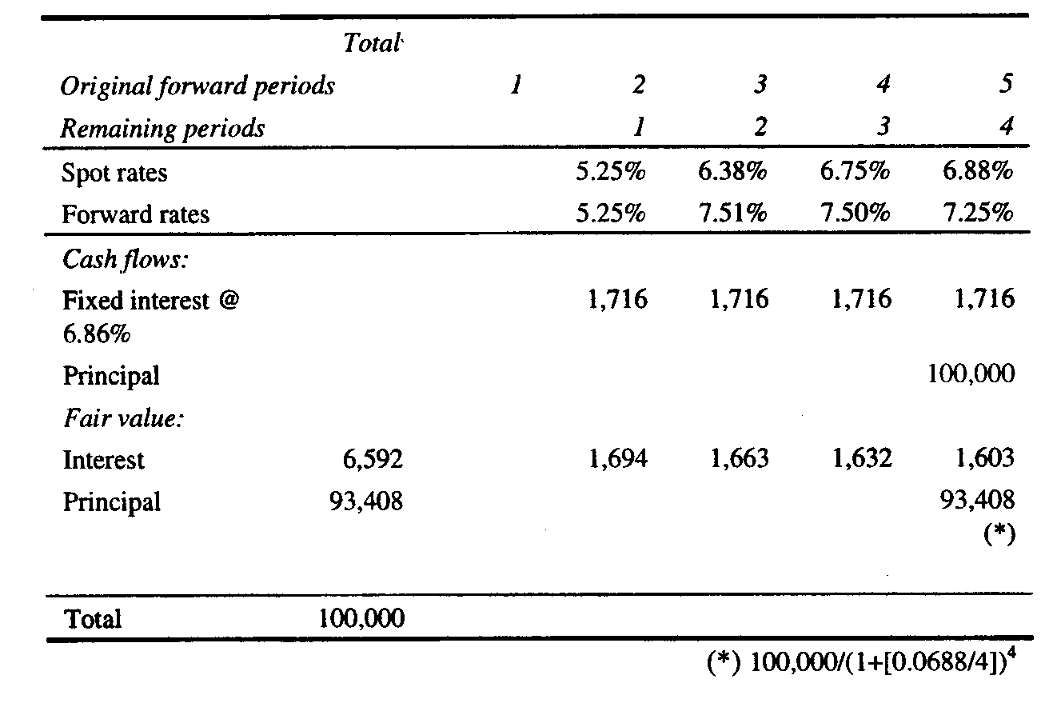

Since it is assumed that interest rates do not change, the fair value of the interest and principal amounts equals the par amount of the forecasted transaction. The fair value amounts are computed based on the spot rates that exist at the inception of the hedge for the applicable periods in which the cash flows would occur had the debt been issued at the date of the forecasted transaction. They reflect the effect of discounting those cash flows based on the periods that will remain after the debt instrument is issued. For example, the spot rate of 6.38% is used to discount the interest cash flow that is expected to be paid in Period 3, but it is discounted for only two periods because it will occur two periods after the forecasted transaction occurs.
The forward interest rates are the same as shown previously, since it is assumed that interest rates do not change. The spot rates are different but they actually have not changed. They represent the spot rates one period forward and are based on the applicable forward rates.

Hedging instrument
The objective of the hedge is to obtain an overall interest rate on the forecasted transaction and the hedging instrument that is equal to 6.86%, which is the market rate at the inception of the hedge for the period from Period 2 to Period 5. This objective is accomplished by entering into a forward starting interest rate swap that has a fixed rate of 6.86%. Based on the term structure of interest rates that exist at the inception of the hedge, the interest rate swap will have such a rate. At the inception of the hedge, the fair value of the fixed rate payments on the interest rate swap will equal the fair value of the variable rate payments, resulting in the interest rate swap having a fair value of zero. The expected cash flows of the interest rate swap and the related fair value amounts are shown as follows:
Table #2
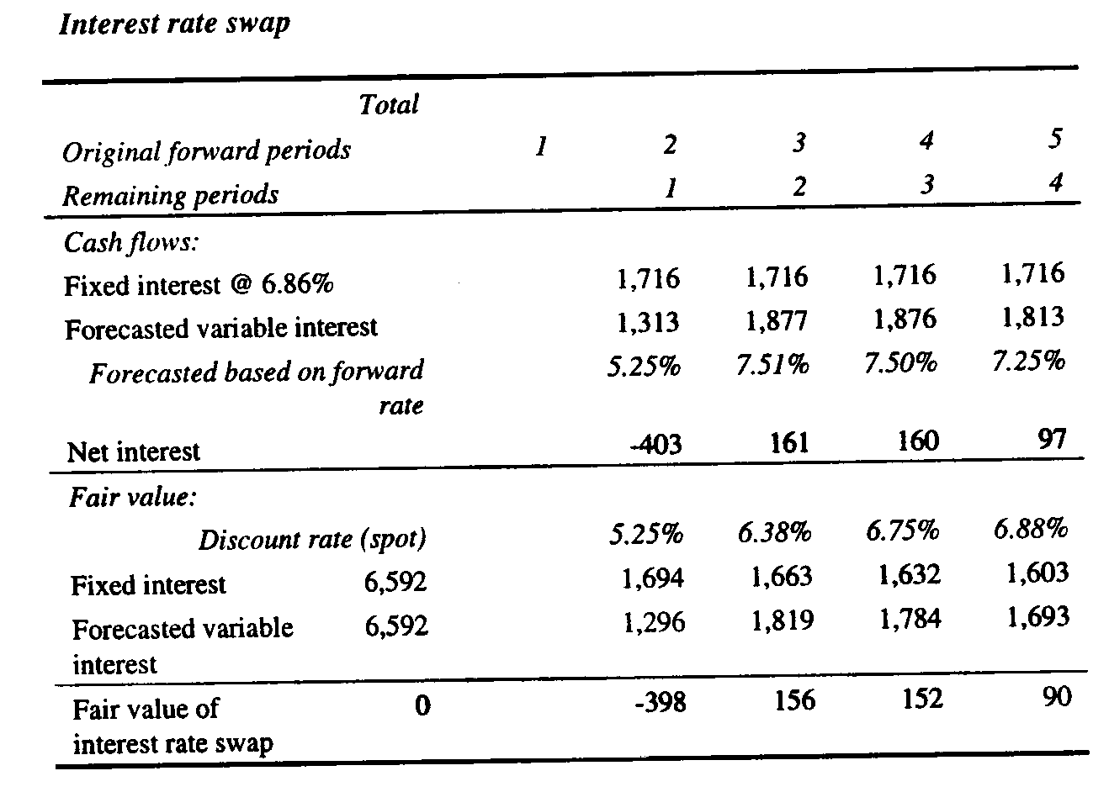
At inception of the hedge, the fixed rate on the forward swap is equal to the fixed rate the enterprise would receive if it could issue the debt in three months under terms that exist today.

Measuring hedge effectiveness
If interest rates change during the period the hedge is outstanding, the effectiveness of the hedge can be measured in a number of ways.
Assume that interest rates change as follows immediately prior to the issuance of the debt at the beginning of Period 2:
Yield curve -- Rates increase 200 basis points
Table #3
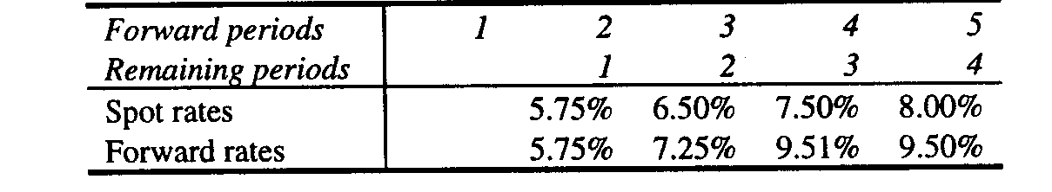

Under the new interest rate environment, the fair value of the pay-fixed at 6.86%, receive-variable interest rate swap which was designated as the hedging instrument would be as follows:
Fair value of interest rate swap
Table #4
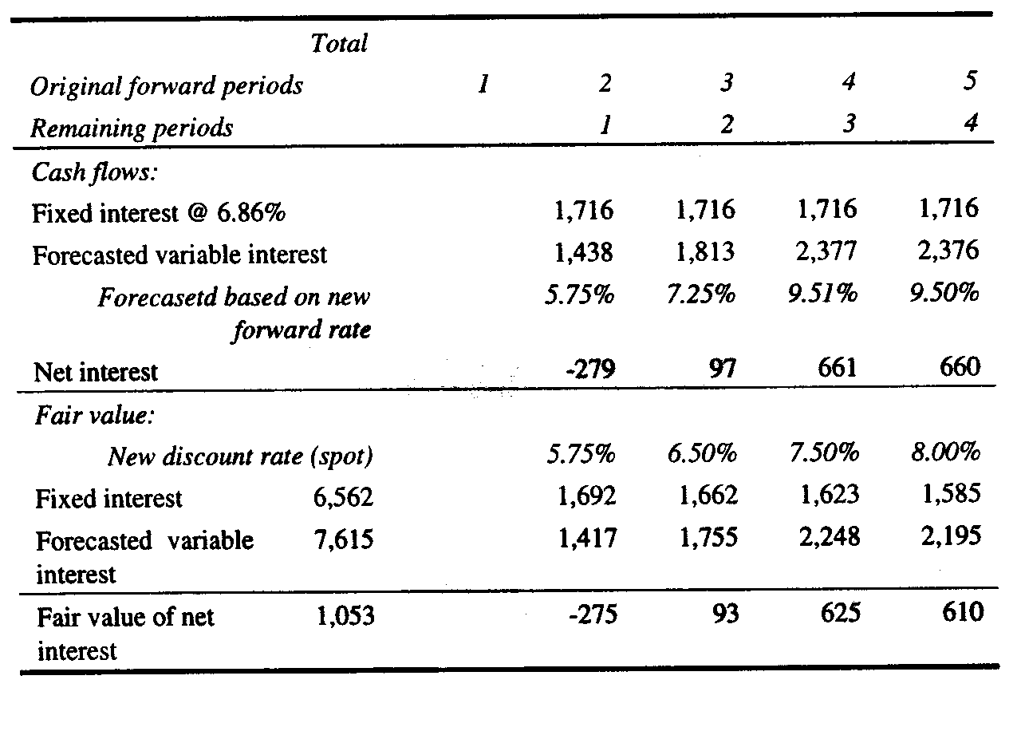
In order to compute the effectiveness of the hedge, it is necessary to measure the change in the present value of the cash flows or the value of the hedged forecasted transaction. There are at least two methods of accomplishing this measurement.
Method A -- Compute change in fair value of debt
Table #5
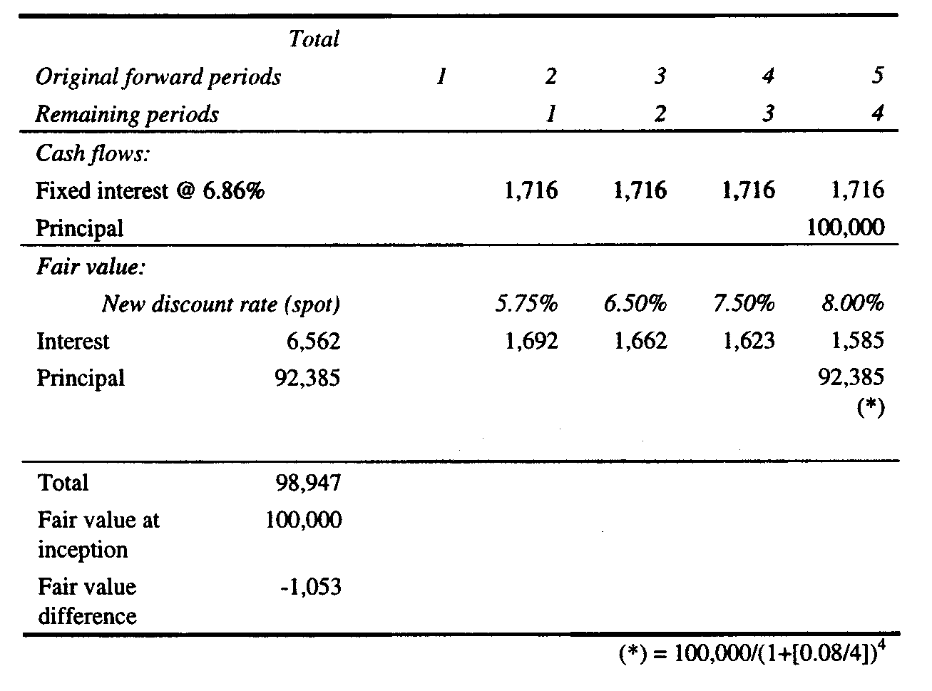
Under Method A, a computation is made of the fair value in the new interest rate environment of debt that carries interest that is equal to the coupon interest rate that existed at the inception of the hedging relationship (6.86%). This fair value is compared with the expected fair value as of the beginning of Period 2 that was calculated based on the term structure of interest rates that existed at the inception of the hedging relationship, as illustrated above, to determine the change in the fair value. Note that the difference between the change in the fair value of the swap and the change in the expected fair value of the debt exactly offset in this example, since the terms of the swap and the forecasted transaction match each other.
Method B -- Compute change in fair value of cash flows
Table #6
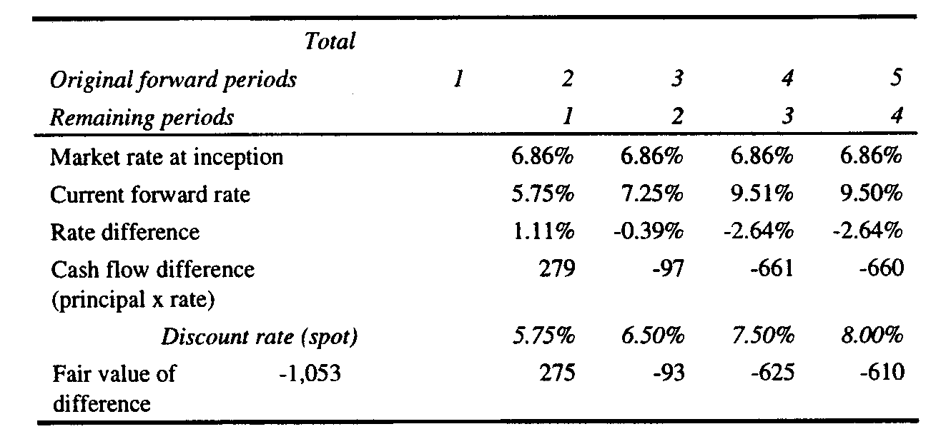
Under Method B, the present value of the change in cash flows is computed based on the difference between the forward interest rates for the applicable periods at the effectiveness measurement date and the interest rate that would have been obtained had the debt been issued at the market rate that existed at the inception of the hedge. The market rate that existed at the inception of the hedge is the one-year forward coupon rate in three months. The present value of the change in cash flows is computed based on the current spot rates that exist at the effectiveness measurement date for the applicable periods in which the cash flows are expected to occur. This method also could be referred to as the "theoretical swap" method (or "hypothetical derivative" method) because the comparison is between the hedged fixed rate on the debt and the current variable rate, which is the same as comparing cash flows on the fixed and variable rate legs of an interest rate swap.
As before, the difference between the change in the fair value of the swap and the change in the present value of the cash flows exactly offset in this example, since the terms match.

Other considerations
There is an additional computation that should be performed to compute ineffectiveness prior to the expected date of the forecasted transaction that has not been considered for purposes of this illustration. The fair value difference has been determined in each of the illustrations as of the expected date of the forecasted transaction immediately prior to the forecasted transaction, that is, at the beginning of Period 2. If the assessment of hedge effectiveness is done before the forecasted transaction occurs, the difference should be discounted to the current date to arrive at the actual amount of ineffectiveness. For example, if the measurement date were one month after the hedging relationship was established and the forecasted transaction is now expected to occur in two months, the amount would have to be discounted for the remaining two months before the forecasted transaction is expected to occur to arrive at the actual fair value. This step would not be necessary in the examples provided above because there was no ineffectiveness. Therefore, additional discounting of the amounts, which net to zero, would not have changed the result.
Under Method B, ineffectiveness is computed based on the difference between the forward coupon interest rates for the applicable periods at the effectiveness measurement date and the interest rate that would have been obtained had the debt been issued at the market rate that existed at the inception of the hedge. Computing the change in cash flows based on the difference between the forward interest rates that existed at the inception of the hedge and the forward rates that exist at the effectiveness measurement date is inappropriate if the objective of the hedge is to establish a single fixed rate for a series of forecasted interest payments. This objective is met by hedging the exposures with an interest rate swap as illustrated in the above example. The fixed interest rate on the swap is a blended interest rate composed of the forward rates over the life of the swap. Unless the yield curve is flat, the comparison between the forward interest rate exposures over the life of the swap and the fixed rate on the swap will produce different cash flows whose fair values are equal only at the inception of the hedging relationship. This difference is shown in the table below:

Table #7
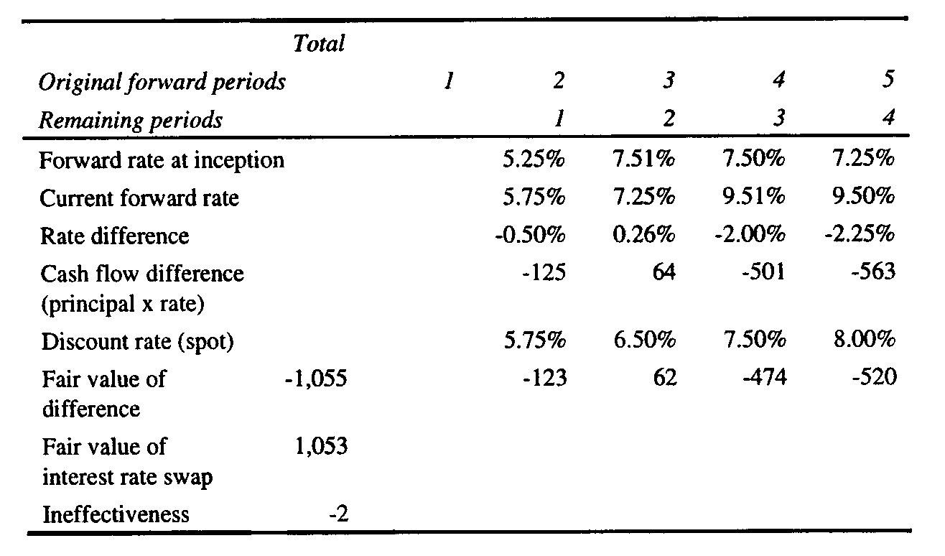
If the objective of the hedge is to obtain the forward rates that existed at the inception of the hedge, the interest rate swap is ineffective because the swap has a single blended fixed coupon rate that does not offset a series of different forward interest rates. However, if the objective of the hedge is to obtain the forward coupon rate that existed at the inception of the hedge, the swap is effective, and the comparison based on differences in forward interest rates suggests ineffectiveness when none may exist. Computing ineffectiveness based on the difference between the forward interest rates that existed at the inception of the hedge and the forward rates that exist at the effectiveness measurement date would be an appropriate measurement of ineffectiveness if the hedging objective is to lock in those forward interest rates. In that case, the appropriate hedging instrument would be a series of forward contracts each of which matures on a repricing date that corresponds with the occurrence of the forecasted transactions.
It also should be noted that it would be inappropriate to compare only the variable cash flows on the interest rate swap with the interest cash flows in the debt that would be generated by the forward interest rates. That methodology has the effect of measuring ineffectiveness only on a portion of the derivative, and IAS 39 does not permit the bifurcation of a derivative for purposes of assessing effectiveness in this situation (IAS 39.144). It is recognized, however, that if the fixed interest rate on the interest rate swap is equal to the fixed rate that would have been obtained on the debt at inception, there will be no ineffectiveness assuming that there are no differences in terms and no change in credit risk or it is not designated in the hedging relationship.

November 23, 2003 message from Ira
Bob,
I've just posted a new article on the Kawaller & Company web site -- "Swap Valuations: The Bank One Swaps Market Precedent". It was published in the latest issue of Risk Magazine, and it was co-authored with John Ensminger and Lou Le Guyader. It may be of particular relevance for those with a tax or regulatory orientation.
If you are interested, you can view it by clicking here: http://www.kawaller.com/pdf/Risk_tax_issues.pdf
(Or copy this link address and past it into the address field in you internet browser.)
You can also go to the Kawaller & Company website to find the following: " Other articles on derivatives, risk management, and related accounting " A schedule of upcoming conferences relating to these topics; and " A description of Kawaller & Co.'s services
Please feel free to contact me with any questions, comments, or suggestions.
Ira Kawaller Kawaller & Company, LLC http://www.kawaller.com
kawaller@kawaller.com 718-694-6270

Casting out on the Internet often results in a catch
Over a year ago I posted a dilemma regarding valuation of interest rate swaps when I attempted to devise a valuation scheme to add to Example 5 in Appendix B of FAS 133 --- http://www.trinity.edu/rjensen/caseans/133ex05d.htm
On March 24, 2005 I received the following message from a nice man that I do not know named Raphael Keymer [raph@gawab.com]

I think I have a solution to your dilema
I’m responding to a ‘dilema’ you posted on the internet concerning recalculation of example 5 for FAS 133. I’ve recalculated the example in question on your web page and believe I’ve resolved the difference.

The Jarrow and Turnbill method was not properly implemented
It turns out the implementation of the ‘Jarrow and Turnbill’ methodology was not correct. When it is properly implemented both valuation methodologies give the same value as the first method employed by you.

Corrections required for Jarrow and Turnbill

Only fixed cash flows on the swap are to be discounted at first
Per the example on pages 435-437, the fixed payments for the swap are considered first, and then only are the floating payments considered. This is calculated (in the worked example) as the present value of the stream of future fixed cash flows. The original implementation used a stream of the latest net cash settlement on reset in place of the stream of fixed cash flows.

The present value of the floating cash flows needs to be calculated
The original implementation didn’t calculate the present value of future floating rate cash flows on the swap.

Interpretation of interest rates was inconsistent with Teets & Uhl
Calculation of discount factors is dependant on the interpretation of the time period related to interest rates. The original Jarrow and Turnbill implementation used interest rates for earlier periods than those used in the Teets & Uhl implementation. This ‘correction’ will have the least effect on valuation differences.

Revised calculations have been attached in a spreadsheet
I placed his attached spreadsheet at http://www.cs.trinity.edu/~rjensen/133ex05aSupplement.xls
My original Example 5 solution is in the 133ex05a.xls Excel workbook at http://www.cs.trinity.edu/~rjensen/
Also see 133ex05.htm at http://www.cs.trinity.edu/~rjensen/
CD Bookmark
You can find answer files at http://www.cs.trinity.edu/~rjensen/
For FAS 133 Appendix B answers, look for files like 133ex01a.xls, 133ex02a.xls, etc.

For the Crystal City November 3, 2006 presentation files and videos that can be downloaded into a CD, go to http://www.cs.trinity.edu/~rjensen/Calgary/CD/

Parent Directory -
AccountingHorizonsDec2005.pdf 13-Jan-2006 13:09 255K Adobe PDF Document
CICA/ 12-Jan-2006 15:10 -
ExamMaterial/ 26-Apr-2004 12:06 -
FAS133AppendixB/ 26-Apr-2004 12:06 -
FAS133OtherExcelFiles/ 25-Mar-2006 11:33 -
Graphing.xls 31-Jan-2006 06:49 107K
JensenGlossary/ 26-Apr-2004 12:06 -
JensenPowerPoint/ 21-Feb-2006 15:42 -
JensenTutorials/ 26-Apr-2004 12:06 -
TheHocusPocusofHedgeAccounting.pdf 31-Jan-2006 15:07 98K Adobe PDF Document
Theory/ 20-Aug-2005 14:26 -
fasb/ 21-Feb-2006 15:41 -
iasb/

Expanding on the fasb folder above you will find the following files, including the FASB standards 123, 133, 138, and 155.

Parent Directory -
0CONTENT.DOC 26-Apr-2004 12:06 20K
133amend.DOC 26-Apr-2004 12:06 186K
133amend.pdf 26-Apr-2004 12:06 134K Adobe PDF Document
DIGindex/ 26-Apr-2004 12:06 -
DebtVersusEquity.pdf 26-Apr-2004 12:06 259K Adobe PDF Document
EDgoodwill.pdf 26-Apr-2004 12:06 176K Adobe PDF Document
ERNST01.DOC 26-Apr-2004 12:06 84K
FAS138.DOC 26-Apr-2004 12:06 248K
FASACsurvey2002.pdf 26-Apr-2004 12:06 326K Adobe PDF Document
FASBvaluationTutorial.pdf 26-Apr-2004 12:06 924K Adobe PDF Document
FVdoc.doc 26-Apr-2004 12:06 138K
FVhtm.htm 26-Apr-2004 12:06 149K
FVjen.htm 26-Apr-2004 12:06 155K
HINTS02.DOC 26-Apr-2004 12:06 26K
Herz050803.doc 26-Apr-2004 12:06 116K
Image1.gif 26-Apr-2004 12:06 3.5K
Image2.gif 26-Apr-2004 12:06 3.6K
Image3.gif 26-Apr-2004 12:06 3.5K
Image4.gif 26-Apr-2004 12:06 3.6K
PVFVALU1.DOC 26-Apr-2004 12:06 200K
PVFVALU2.DOC 26-Apr-2004 12:06 73K
SFAS105.DOC 26-Apr-2004 12:06 253K
SFAS107.DOC 26-Apr-2004 12:06 195K
SFAS119.DOC 26-Apr-2004 12:06 257K
SFAS130.DOC 26-Apr-2004 12:06 216K
SFAS131.DOC 26-Apr-2004 12:06 206K
SPE140.pdf 26-Apr-2004 12:06 137K Adobe PDF Document
VoluntaryDisclosures01.pdf 26-Apr-2004 12:06 253K Adobe PDF Document
busrep.pdf 26-Apr-2004 12:06 295K Adobe PDF Document
ed213b.doc 26-Apr-2004 12:06 360K
ed213c.doc 26-Apr-2004 12:06 59K
fairval.htm 26-Apr-2004 12:06 1.8K
fas141and142/ 26-Apr-2004 12:06 -
goodwill.DOC 26-Apr-2004 12:06 45K
iaspaul1.doc 26-Apr-2004 12:06 195K
iaspaul2.doc 26-Apr-2004 12:06 23K
intaniblesproposal.htm 26-Apr-2004 12:06 52K
intnacct.htm 26-Apr-2004 12:06 82K
jwg01.pdf 26-Apr-2004 12:06 1.1M Adobe PDF Document
linsmeir.ppt 26-Apr-2004 12:06 498K
sfas123.htm 26-Apr-2004 12:06 423K
sfas123/ 26-Apr-2004 12:06 -
sfas133/ 26-Apr-2004 12:06 -
sfas138/ 21-Sep-2006 13:55 -
sfas149/ 26-Apr-2004 12:06 -
sfas155/ 21-Feb-2006 15:41 -
uptonApril01.pdf 26-Apr-2004 12:06 700K Adobe PDF Document

You can download the FASB standards and related documents from http://www.fasb.org/

You can download the IASB standards from http://www.iasb.org/Home.htm

Bob Jensen's Archives of New Bookmarks --- http://www.trinity.edu/rjensen/Bookurl.htm
Bob Jensen's Tidbits Blog --- http://www.trinity.edu/rjensen/TidbitsDirectory.htm
Bob Jensen's Updates on Fraud --- http://www.trinity.edu/rjensen/FraudUpdates.htm
Links to Documents on Fraud --- http://www.trinity.edu/rjensen/Fraud.htm
Bob Jensen's search helpers are at http://www.trinity.edu/rjensen/searchh.htm
Bob Jensen's Bookmarks --- http://www.trinity.edu/rjensen/bookbob.htm
Bob Jensen's links to free electronic literature, including free online textbooks --- http://www.trinity.edu/rjensen/ElectronicLiterature.htm
Bob Jensen's links to free online video, music, and other audio --- http://www.trinity.edu/rjensen/Music.htm
Bob Jensen's documents on accounting theory are at http://www.trinity.edu/rjensen/theory.htm
Bob Jensen's links to free course materials from major universities --- http://www.trinity.edu/rjensen/000aaa/updateee.htm#OKI
Bob Jensen's links to online education and training alternatives around the world --- http://www.trinity.edu/rjensen/Crossborder.htm
Bob Jensen's links to electronic business, including computing and networking security, are at http://www.trinity.edu/rjensen/ecommerce.htm
Bob Jensen's links to education technology and controversies --- http://www.trinity.edu/rjensen/000aaa/0000start.htm
Bob Jensen’s home page is at http://www.trinity.edu/rjensen/
Robert (Bob) Jensen
Emeritus Accounting Professor From Trinity University
190 Sunset Hill Road
Sugar Hill, NH 03586
Phone: 603-823-8482
email: rjensen@trinity.edu

