An Explanation of the Receive Fixed/Pay Variable Interest Rate Swap in Example 2
Illustrating the Application of SFAS 133
(Forthcoming in Derivatives Review)

Carl M. Hubbard and Robert E. Jensen
Trinity University
San Antonio, Texas

Introduction

In 1998, the Financial Accounting Standards Board (FASB) issued the a derivatives and hedge accounting SFAS 133 (or FAS 133) standard that will be one of the most costly and confusing of all FASB standards to implement. You can read more about SFAS 133 and other FASB standards at http://www.rutgers.edu/Accounting/raw/fasb/st/stpg.html. Note that the FASB's SFAS 133 becomes required for calendar-year companies on January 1, 2001. Early adopters can apply the standard prior to the required date, but they cannot apply it retroactively. The January 1, 2001 effective date follows postponements from the original starting date of June 15, 1999 stated in Paragraph 48 on Page 29 of SFAS 133. For fiscal-year companies, the effective date is June 15, 2000. The international counterpart, known as the International Accounting Standards Committee (IASC) IAS 39, becomes effective for financial statements for financial years beginning on the same January 1, 2001. Earlier application permitted for financial years ending after 15 March 1999. For SFAS 133 in the United States, ordering information is given below:
Publication Number 186-B, June 1998, Product Code S133
FASB Statement No. 133, Accounting for Derivative Instruments and Hedging Activities
Telephone (800) 748-0659 or go to web site http://www.rutgers.edu/Accounting/raw/fasb/home2.html

SFAS 133 is the most difficult and confusing standard ever issued by the FASB. It is the only standard to be followed by a FASB standard implementation group that addresses the many implementation concerns of companies. That group known as the Derivatives Implementation Group (DIG) publishes issues and conclusions at http://www.rutgers.edu/Accounting/raw/fasb/map/index.html. SFAS 133 is also the only standard for which a CD-ROM study guide was prepared by the FASB. See http://www.rutgers.edu/Accounting/raw/fasb/CDROM133.html.

Objectives of this Paper

This paper is the first of two papers intended to help readers cope with the two most difficult illustrations in SFAS 133. Both illustrations refer to using yield curves to estimate value adjustments to interest rate swaps. But in neither example nor in the entire standard can readers find how such yield curves are used in derivations. These are in fact missing gaps in SFAS 133. The present paper is devoted to Example 2 beginning in Paragraph 111 of SFAS 133. A companion paper will focus on Example 5 beginning in Paragraph 131. These two examples have more missing gaps than the other Appendix B illustrations in SFAS 133.

In particular, in Example 2 there is a summary of results table in Paragraph 171 of SFAS 133. However, it is never explained how many of the numbers are derived. The yield curves are not specified such that there is no foundation on which to derive the interest accruals and amortizations of basis adjustments. We do provide some guidance and illustrate how the results might be obtained under our assumed yield curves in the 133ex02.xls file that can be downloaded from http://www.cs.trinity.edu/~rjensen/. Downloading instructions are given in the 1330tut.htm file at that web site.

Example 2 focuses upon an application of SFAS 133 by a company that has entered into a swap contract to receive a fixed interest rate and pay variable rates over an 8-quarter period. The debtor company’s objective is to pay the variable rate on the company’s 2-year fixed rate debt while maintaining the 8-quarter fixed maturity of the fixed rate debt. Whether the debtor benefits from the swap depends on whether variable rates are mostly lower than the fixed rate during the life of the debt. Since the receive fixed/pay variable swap offsets the debtor’s fixed interest rate expense by the fixed interest received in the swap, the debtor company expects variable rates to be lower than the fixed rate. If variable rates are generally lower than the fixed rate received during the swap, the debtor receive payments in the receive fixed/pay variable swap thus lowering the total interest expense on the debt. If short-term rates rise, the company would make a swap payments and incur greater interest expense than the fixed rate on the debt. Since the debt is paid at maturity, there is no interest rate swap net settlement balance payable or receivable at maturity. The purpose of this paper is to explain the figures given in the table in Paragraph 11r of SFAS 133 that illustrates accounting for this fair value, effective swap. First, though, we introduce some things to consider before getting into technical details.

Introduction to Example 2 in SFAS 133

Example 2 in Paragraphs 111-120 of SFAS 133 focuses upon an interest rate swap to hedge the fair value of fixed-rate debt. Paragraph 115 reads as follows:

Paragraph 115. On July 1, 20X1. ABC Company borrows $1,000.000 to be repaid on June 30, 20X3. On that same date, ABC designates the interest rate swap as a hedge of the changes in the fair value of the fixed-rate debt attributable to changes in market interest rates.

 | Interest Rate Swap | Fixed-Rate Debt
Trade date and borrowing date | July 1, 20X1 | July 1, 20X1
Termination date and maturity date | June 30, 20X3 | June 30, 20X3
Notional amount and principal amount | $1,000,000 | $1,000,000
Fixed interest rate received | 6.41% | 6.41%
Variable interest rate paid | 3-month US$ LIBOR | NA
Settlement dates and interest payment dates | Quarterly (Calendar) | Quarterly (Calendar)
Reset dates | Quarterly (Calendar) | NA

Paragraph 116. The US$ LIBOR rates that are in effect at inception of the hedging relationship and at each of the quarterly reset dates are assumed to be as follows:
Reset Date | 3-Month LIBOR Rate
7/ 1/X1 | 6.41%
9/30/X1 | 6.48%
12/31/X1 | 6.41%
3/31/X2 | 6.32%
6/30/X2 | 7.60%
9/30/ X2 | 7.71%
12/31/ X2 | 7.82%
3/31/X3 7.42% | 3/31/X3 7.42%

Yield Curves

In the introductory Paragraph 111, the Example 2 begins with the assumption of a flat yield curve. A yield curve is the graphic or numeric presentation of bond equivalent yields to maturity on debt that is identical in every aspect except time to maturity. In developing a yield curve, default risk and liquidity, for example, are the same for every security whose yield is included in the yield curve. Thus yields on U. S. Treasury issues are normally used to plot yield curves. The relationship between yields and time to maturity is often referred to as the term structure of interest rates.

As explained by the expectations hypothesis of the term structure of interest rates, the typical yield curve is gradually increase relative to maturity. That is, in normal economic conditions short-term rates are somewhat lower than longer-term rates. In a recession with deflation or disinflation the entire yield curve shifts downward as interest rates generally fall and rotates indicating that short-term rates have fallen to much lower levels than long-term rates. In an economic expansion accompanied by inflation, interest rates tend to rise and yield curves shift upward and rotate indicating that short-term rates have increased more than long-term rates.

The different shapes of the yield curve described above complicate the calculation of the present value of an interest rate swap and require the calculation and application of implied forward rates to discount future fixed rate obligations and principal to the present value. Fortunately Example 2 assumes that a flat yield curve prevails at all levels of interest rates. A flat yield curve means that as interest rates rise and fall, short-term and long-term rates move together in lock step, and future cash flows are all discounted at the same current discount rate.

SFAS 133 and IAS 39 Glossary

One of the frustrations of working with SFAS 133 is that there is no index provided by the FASB. Help is available along with a glossary, web links, and transcriptions of experts at http://www.trinity.edu/rjensen/acct5341/speakers/133glosf.htm. What is especially important about this free online glossary is that terms are cross-referenced to Paragraphs in SFAS 133. Cross-referencing for IAS 39 will soon be available as well.

In connection with Examples 2 and 5 in SFAS 133, it may be useful to examine the section on “Yield Curve” in the above glossary. Among other things, that section provides links to sources of yield curves which for interest rate swaps are often called swaps curves.

SFAS 133 Online Tutorials Note that you can download an Excel workbook that more fully explains the derivation of each number in the above table. Download 133ex02a.xls and click on the Explanations tab from http://www.cs.trinity.edu/~rjensen/
Note that you can download an Excel workbook that more fully explains the derivation of each number in the above table. Download 133ex02a.xls and click on the Explanations tab from http://www.cs.trinity.edu/~rjensen/

Bob Jensen provides some free SFAS 133 tutorials and cases that you can download from http://www.cs.trinity.edu/~rjensen/13300tut.htm. In particular, the tutorials for Example 2 featured in this paper are contained in the 133ex02a.xls workbook. Note that you can download an Excel workbook that more fully explains the derivation of each number in the above table. Download 133ex02a.xls and click on the Explanations tab from http://www.cs.trinity.edu/~rjensen/. Note especially that Sheet 4 of that Excel workbook explains the yield curve (swap curve) derivations for Example 2.

Recalculating the Paragraph 117 Table Illustrating Example 2 Accounting

The Example 2 results table given in Paragraph 117 of SFAS 133 is reproduced in the appendix of this paper as Appendix Exhibit 1. The appendix table is identical to the example table except that we have included a column that lists the relevant LIBOR changes that cause variations in the value of the fixed rate debt and give rise to swap payments and receipts. In the Paragraphs below, sections of the table are reproduced to facilitate the explanations of the calculations of the amounts in the table.

July 1, 20X1 to September 30, 20X1
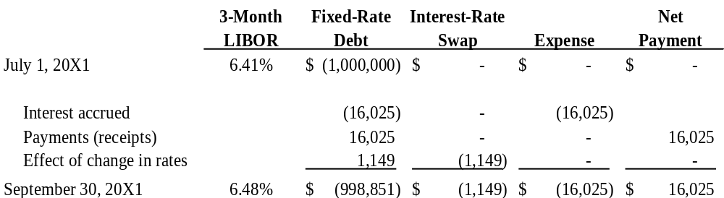

July 1, 20X1 is the issuance date of the 2-year or 8-quarter fixed rate debt and the principal amount is $1,000,000. The LIBOR of 6.41% on July 1, 20X1 is the fixed rate to be applied to the principal of $1,000,000 in calculating periodic accrued interest and interest payments for the term of the debt.

At the end the first quarter on September 30, 20X1, the accrued interest on the debt is paid. The quarterly interest expense and payment is 0.0641/4 x $1,000,000. Since the LIBOR rose to 6.48% as of September 30, 20X1, the debt is revalued. The seven remaining quarterly interest payments and the principal are discounted to the present value using 0.0162 (0.0648/4) as the discount rate. The value of the debt is now $998,851 which represents a discount of $1,149 from the principal. As in all quarters in the example, the end of quarter value of the debt also is the sum of the figures in the column above it. The discount at the end of this first quarter is identified in the table as “Effect of change in rates” on the debt and as the amount of the net settlement payable on the interest rate swap. Because 9/30/X1 is the end of the first quarter of the life of the debt and the swap, there is no amortization of the basis adjustment or accrued interest (payable) or receivable on the previous quarter’s net swap settlement zero balance.

September 30, 20X1 to December 31, 20X1
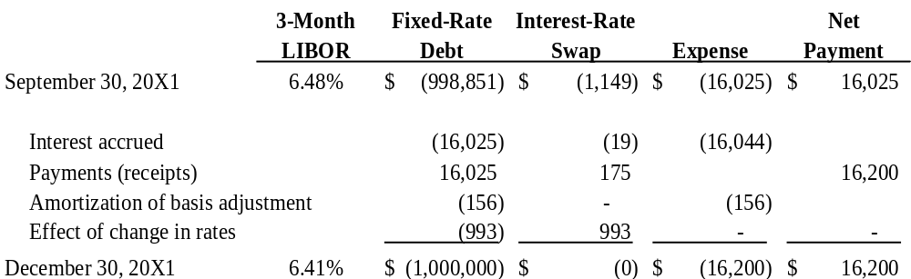

At the end the second quarter on December 31, 20X1, the accrued interest expense of $16,025 is paid. Since the LIBOR decreased to 6.41% on 12/31/X1, the value of debt increased to the original principal value of $1,000,000. The “Amortization of the basis adjustment” is tied to the previous quarter’s discount or premium in the value of the debt. The ($156) amortization figure is the quarterly ordinary annuity whose future value compounded at the LIBOR of 6.48%/4 from the end of the previous period to the end of the 8th quarter is equal to the $1,149 discount in the value of the debt on 9/30/X1.

The “Effect of change in rates” of ($993) on the value of the debt plus the amortization of basis adjustment of ($156) is equal to the $1,149 increase in the value of the debt on 12/31/X1. The accrued interest payable of ($19) on beginning period net settlement balance is the LIBOR/4 at the beginning of the quarter (0.0648/4 = 0.0162) times the net settlement balance on 9/30/X1 of ($1,149). The $175 interest rate swap payment is the difference between the variable rate paid as of the beginning of the quarter (6.48%) and the fixed rate received in the swap (6.41%) on a quarterly basis times the principal value of the debt, or (0.0648 – 0.0641)/4 x $1,000,000 = $175). The interest rate swap payment of $175 is also the sum of the interest payable accrued on the swap of ($19) and the amortization of the basis adjustment of ($156). For the quarter ending 12/31/X1 the company’s total interest expense was $16,200, which is higher than it would have been without a swap.

December 31, 20X1 to March 31, 20X2

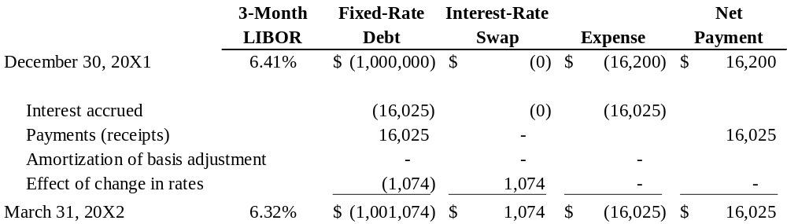

At the end the third quarter on March 31, 20X1, the accrued interest expense of $16,025 is paid. The LIBOR decreased again to 6.32% on 3/31/X1, and the present value of debt increased to $1,001,074. Since there was no discount or premium in the value of the debt at the end of the previous quarter, there is no current period “Amortization of basis adjustment.” The current quarter’s “Effect of change in rates” of $1,074 is equal to the $1,074 gain in value of the debt due to the interest rate decline. Since the net settlement balance is a receivable, the accrued interest payable on the interest rate swap payable balance from the previous period is zero. It also follows that since the variable rate equaled the fixed rate at the end of the previous quarter there are no swap payments in the current period, and total interest the total expense and payments is $16,025.

March 31, 20X2 to June 30, 20X2
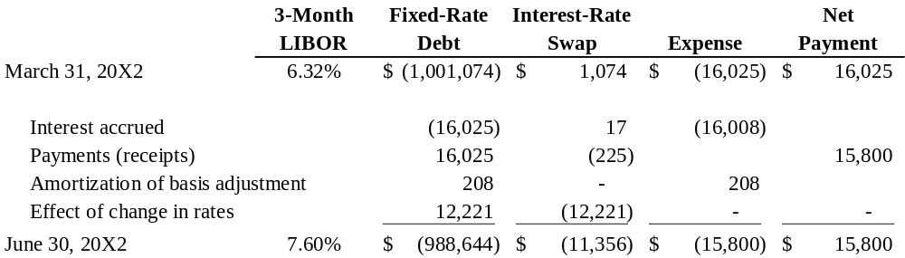

At the end of the 3/31/X2 - 6/30/X2 quarter the LIBOR had risen to 7.60%, and the present value of the debt, of course, fell from a premium to a discounted value. The present value of the remaining cash flows of the debt – ($988,644) - is also the sum of the figures above it from ($1,001,074) through $12,221. Since the value of the debt at the end of the previous quarter included a $1,074 premium, there is an amortization of basis adjustment. The $208 figure is the quarterly ordinary annuity whose future value compounded at the LIBOR of 6.32%/4 is equal to the previous period’s $1,074 premium in the value of the debt. The current period’s “Effect of change in rates” is $12,221, which when added to the amortization of basis of $205 equals the change in the value of the debt from 3/31/X2 to 6/30/X2.

Since the previous period ended with a net swap balance receivable, there is an accrual of interest receivable of $17 which is (0.0614 - 0.0632)/4 x $1,074. The interest rate swap receipt of $225 is the sum of the accrued interest receivable of $17 plus the amortization of basis of $205. Because of the decline of the LIBOR in the previous period, the current period’s accrued interest and interest expense is $15,800 or $16,025 - $225. Thus the company benefited from the swap in the 3/31/X2 to 6/30/X2 quarter.

June 30, 20X2 to September 30, 19X2
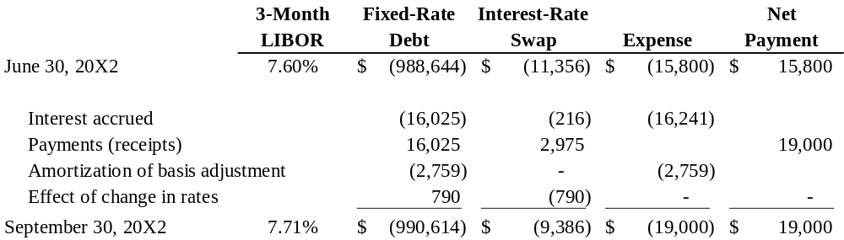

At the beginning of the quarter the LIBOR was 7.60% which resulted in a discount in the present value of the company’s debt. The current quarter “Amortization of the basis adjustment,” which is tied to the previous quarter’s discount or premium in the value of the debt, is ($2,759). ($2,759) is the quarterly ordinary annuity whose future value compounded at the LIBOR of 7.60%/4 from the end of the previous period to the end of the 8th quarter is equal to the $11,356 beginning period discount in the value of the debt. The “Effect of change in rates” of $790 on the value of the debt plus the amortization of basis adjustment of ($2,759) is equal to the ($1,970) increase in the value of the debt from 6/30/X2 to 9/30/X2.

The accrued interest payable of ($216) on beginning period net settlement balance is the LIBOR/4 at the beginning of the quarter (0.076/4) times the net settlement balance on 6/30/X2 of ($11,356). The $2,975 interest rate swap payment is the difference between the variable rate to be paid (7.60%) and the fixed rate received in the swap (6.41%) on a quarterly basis times the principal value of the debt, or (0.076 – 0.0641)/4 x $1,000,000 = $2,975. The interest rate swap payment of $2,975 is also the sum of the interest accrual on the swap of ($216) and the amortization of the basis adjustment of ($2,759). For the quarter ending 9/30/X2 the company’s total interest expense was $19,000, which is higher than it would have been without a swap.

Since the debt is approaching maturity with only 3 quarters remaining on 9/30/X2, the value of the debt increased in spite of an increase in the LIBOR. The convergence of the present value of the debt to the principal value as the maturity date approaches means that there will be no discount or premium in the present value of the debt on the maturity date of 6/30/X3. The ultimate equality of the present value and the principal value of the debt guarantees a zero net settlement balance of the interest rate swap on the maturity date.

Remaining Quarters

The figures in the remaining quarters are calculated in the manner described in the Paragraphs above. The LIBOR remains above the fixed rate received in the swap by the debtor, and interest swap payments are made in each remaining quarter. Accrued interest on the interest rate swap is calculated on the previous quarter’s net settlement balance times the LIBOR/4 at of the end of the previous quarter. The “Amortization of basis adjustment” approaches the discount in the value of the debt as the maturity date approaches. The “Effect of change in rates” ultimately is zero as the debt is repaid at the end of the 8th quarter.

Concluding Remarks

As stated above, whether the received fixed/pay variable debtor ultimately benefits from the swap depends on whether the rate received in the swap is higher than the rate paid. In this example the debtor swap worked against the company, as variable rates paid were generally above the fixed rate received. Total interest expense including swap payments and receipts were $140,425 in comparison to $128,200 had there been no swap. Clearly this is not a hedge but rather a conversion of the fixed rate debt to variable rate debt with a fixed maturity date.
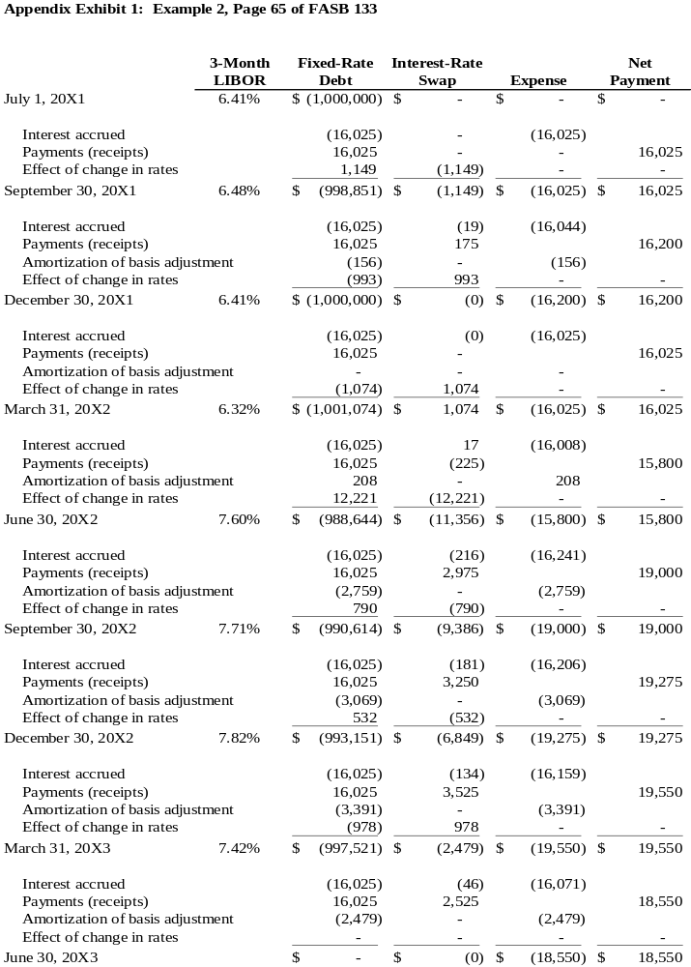Note that you can download an Excel workbook that more fully explains the derivation of each number in the above table. Download 133ex02a.xls and click on the Explanations tab from http://www.cs.trinity.edu/~rjensen/

Endnote

See Chapter 6 “The Term Structure of Interest Rates” in James C. Van Horne Financial Market Rates and Flows, 5th Edition. Upper Saddle River, NJ: 1998 for an excellent discussion of yield curves.

